Gender Equity | - No. of health /sensitization programmes organised  - % of students benefited  - Women anti sexual harassment committee constituted as per norms  - Grievances Redessal as per timeline | 1.a) A digital literary drive was organised by the SPARSH cell in  collaboration with HESPL on 21- 22 October 2024. The female students were taught about e- Governance services. 400 students took part in this event.  b) The Women Cell and SPARSH organised an insightful lecture on the “Legal Rights of Women” on 14 February 2025. Advocate Mamta Bansal shared her expertise on the topic.100 students took part in the event.  c) A Health checkup was organised by SPARSH in collaboration with Glenmark Foundation on 8 March 2025 by Dr. Anjali and her team. Around 100 students benefited by the program.  d) A two-day workshop on “Mahila Sashaktikaran” was organised by women cell on 7-8 March, 2025. The program was graced by Hon’ble MLA Shri Hardeep Singh Bawa, where students presented cultural performances, including dance, motivational speech, poster making etc. Around 300 students were present at the event.  e) A lecture on “Menstrual health and hygiene practices” was organised by SPARSH on 7 March 2025. Dr. Anjali Goyal from IRG and Glenmark Foundation addressed the students. 150 students took part in the event.  - 72.77%  - Yes  - Yes
Facilities for Specially abled Students | - Ramps/wheelchairs/ support railing  - Separate washrooms | - Yes; The college campus is specially abled friendly that includes ramps and railings in the premises. The main entrance of the college also has ramp.  - Yes
Facilities for students | - Common room for girls  - Adequate toilets as per students’ strength  - Sanitary napkins vending machine/ incinerator regularly put in use  - CSCA room with proper furniture  - Student Centre for co - curricular activities and its regular usage  - Regular use of playground | - It is available in Science Block of the college Room no. 12)  - Science Block-6 : Arts Block-5  Details of Toilets:  Science Block: Girls-2; Boys – 1 ; Staff-1  Arts Block : Girls-1; Boys-2; staff-3  3. 2 vending machine and 2 incinerators  4. Yes  - Canteen cum student centre  6. Well maintained huge playground regularly used by students of the college as well as local population of town with prior permission from the Head of the Institution. Separate Basketball Court is also available in the college.

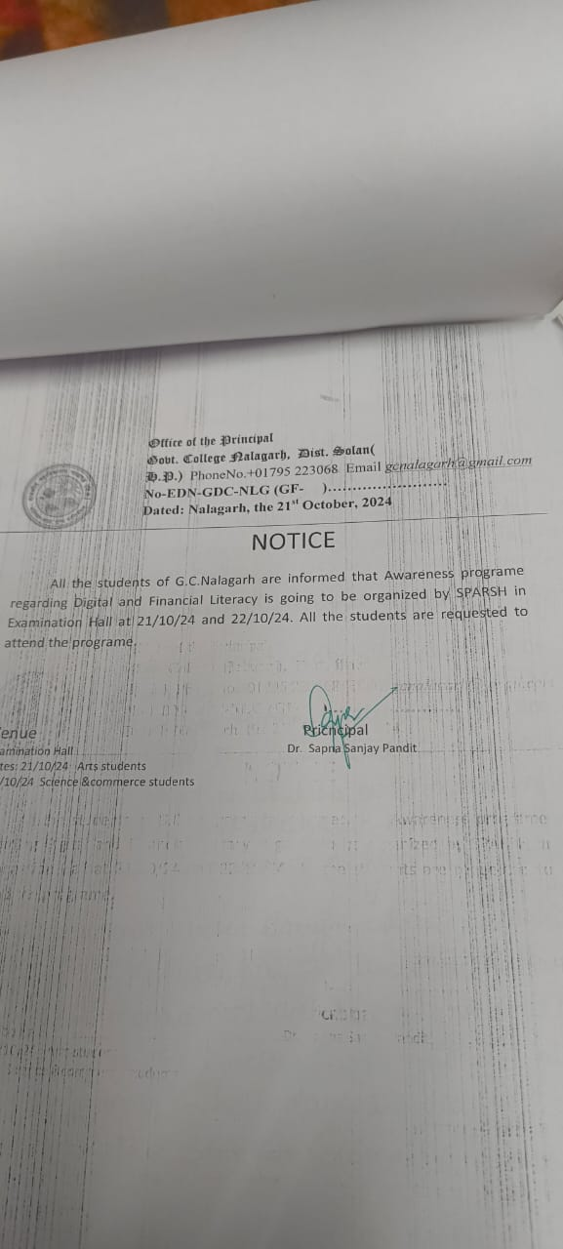
Picture 1. Document for Awareness Program Regarding Digital and Financial Literacy

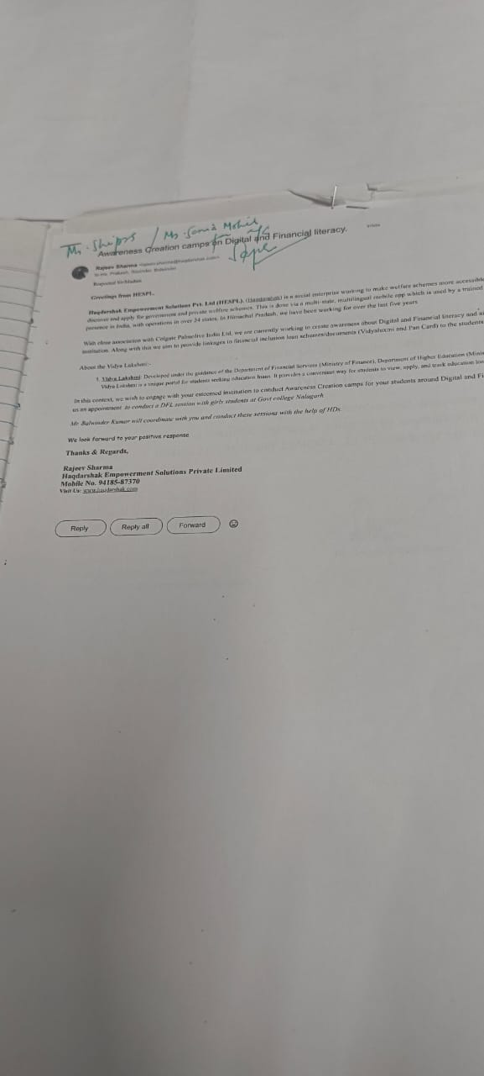
Picture 2. Document for Awareness Program Regarding Digital and Financial Literacy

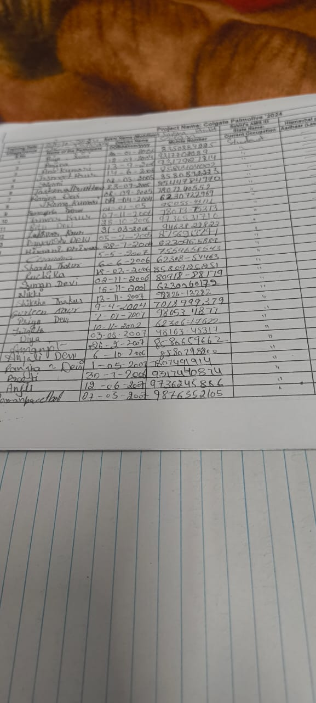
Picture 3. Document for Awareness Program Regarding Digital and Financial Literacy

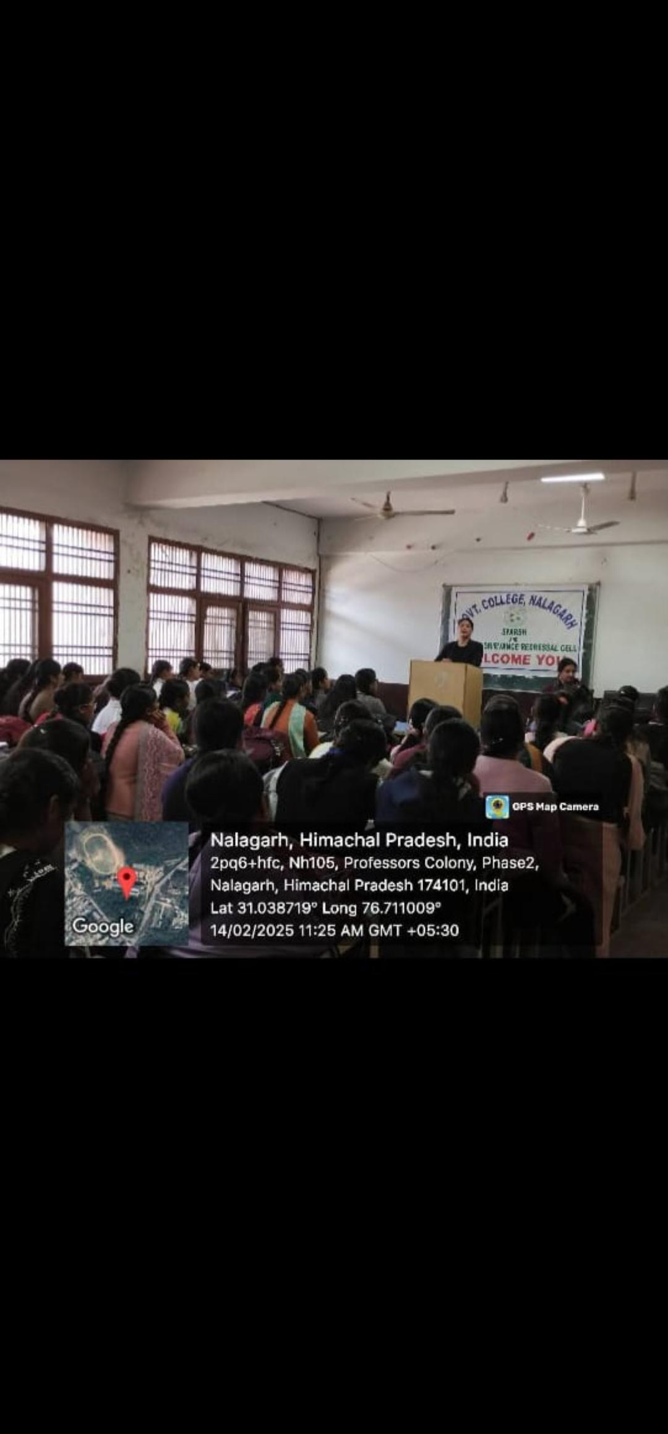
Picture 4. Organized a Lecture on Legal Rights of Women on 14.02.2025 by Advocate Mamta Bansal

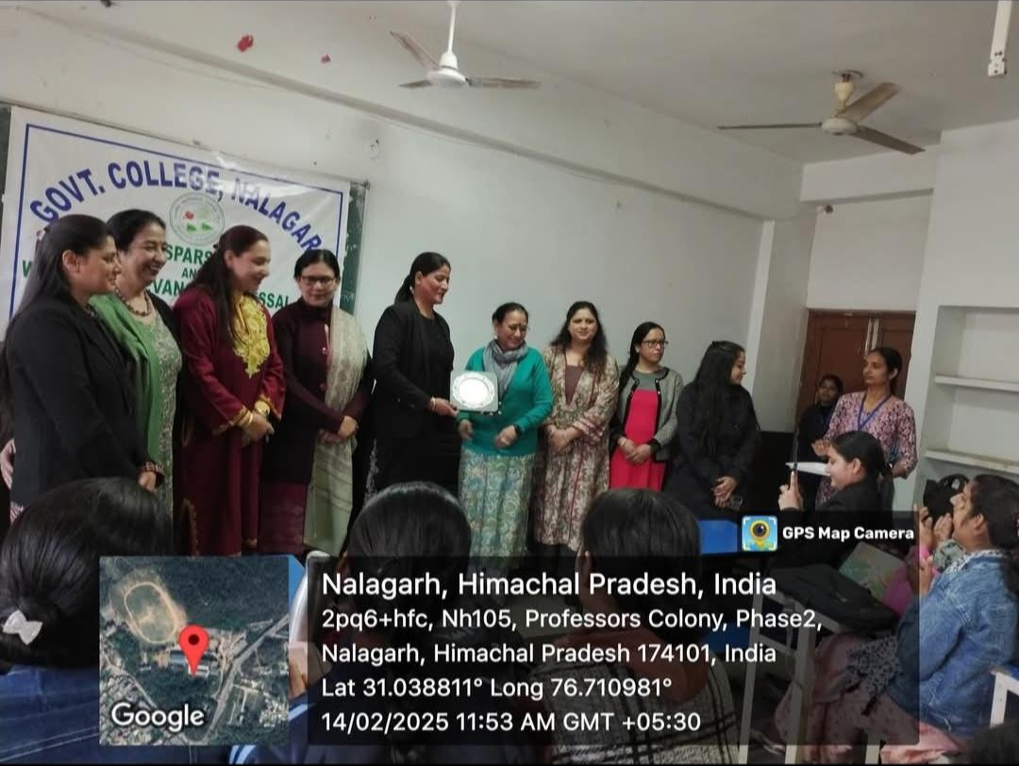
Picture 5. Organized a Lecture on Legal Rights of Women on 14.02.2025 by Advocate Mamta Bansal

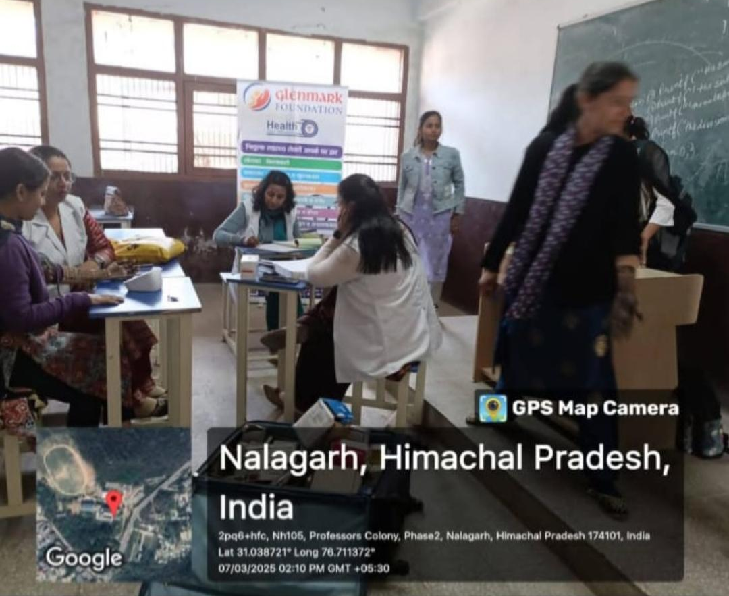
Picture 6. Health Check-up Program Organzined in the Presence of Dr.Anjali and Her Team
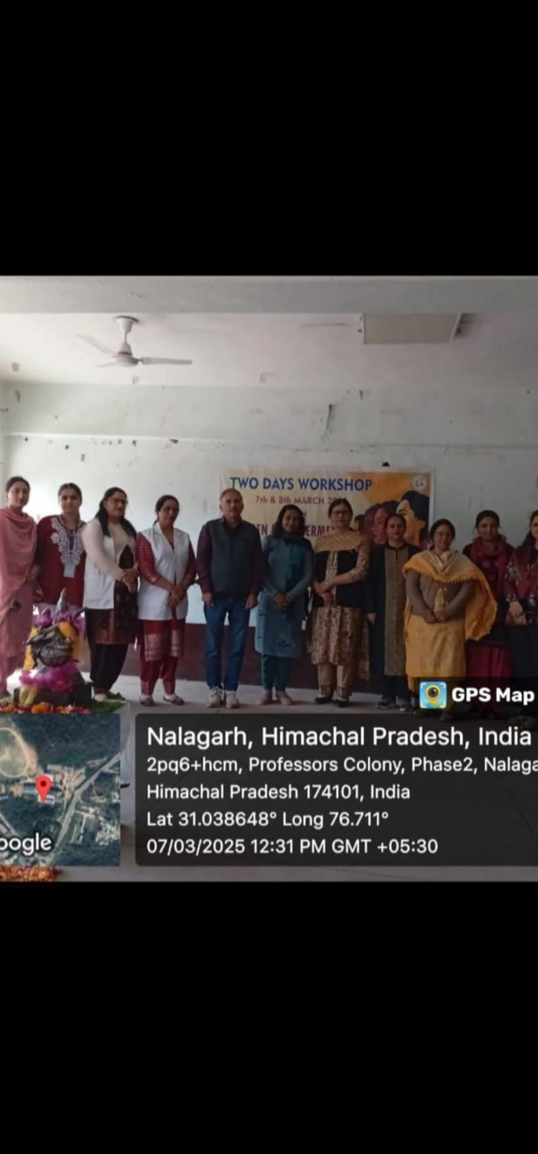
Picture 7. Health Check-up Program Organzined in the Presence of Dr.Anjali and Her Team

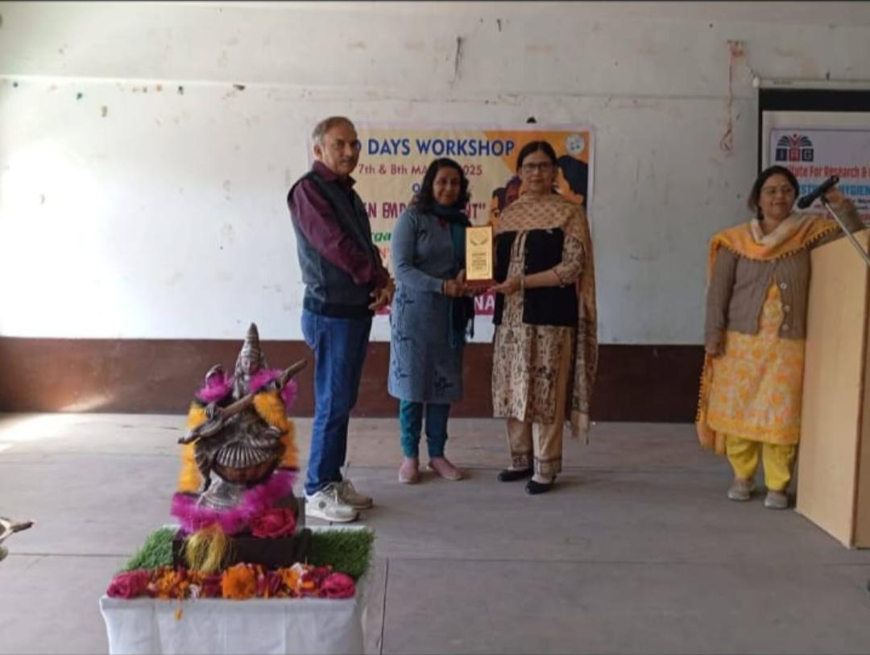
Picture 8. Two-Day Workshop on International Women’s Day

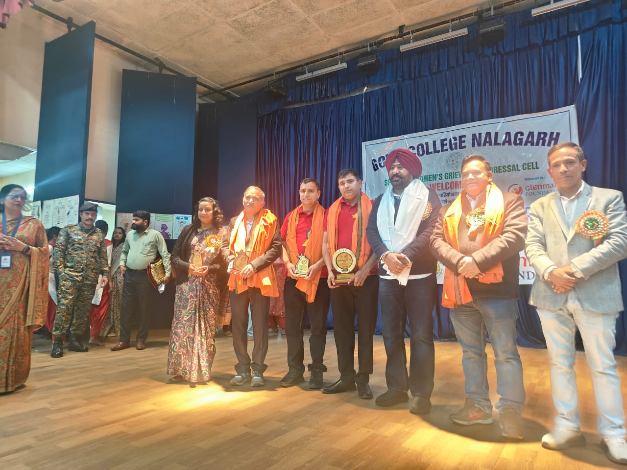
Picture 9. Two-Day Workshop on International Women’s Day

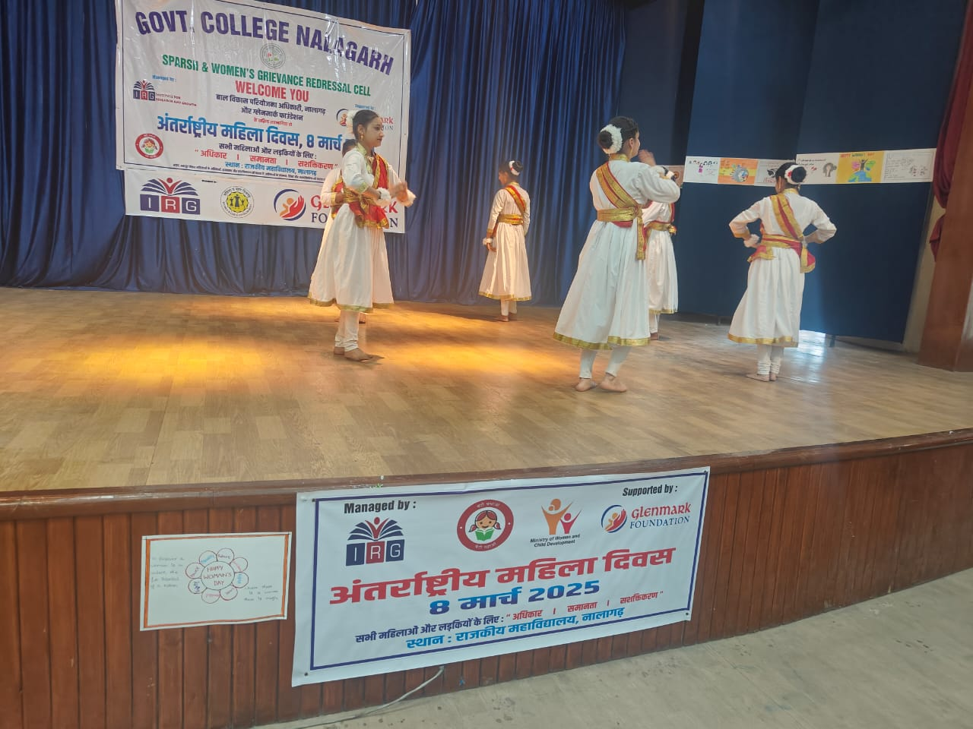

Picture 10. Two-Day Workshop on International Women’s Day
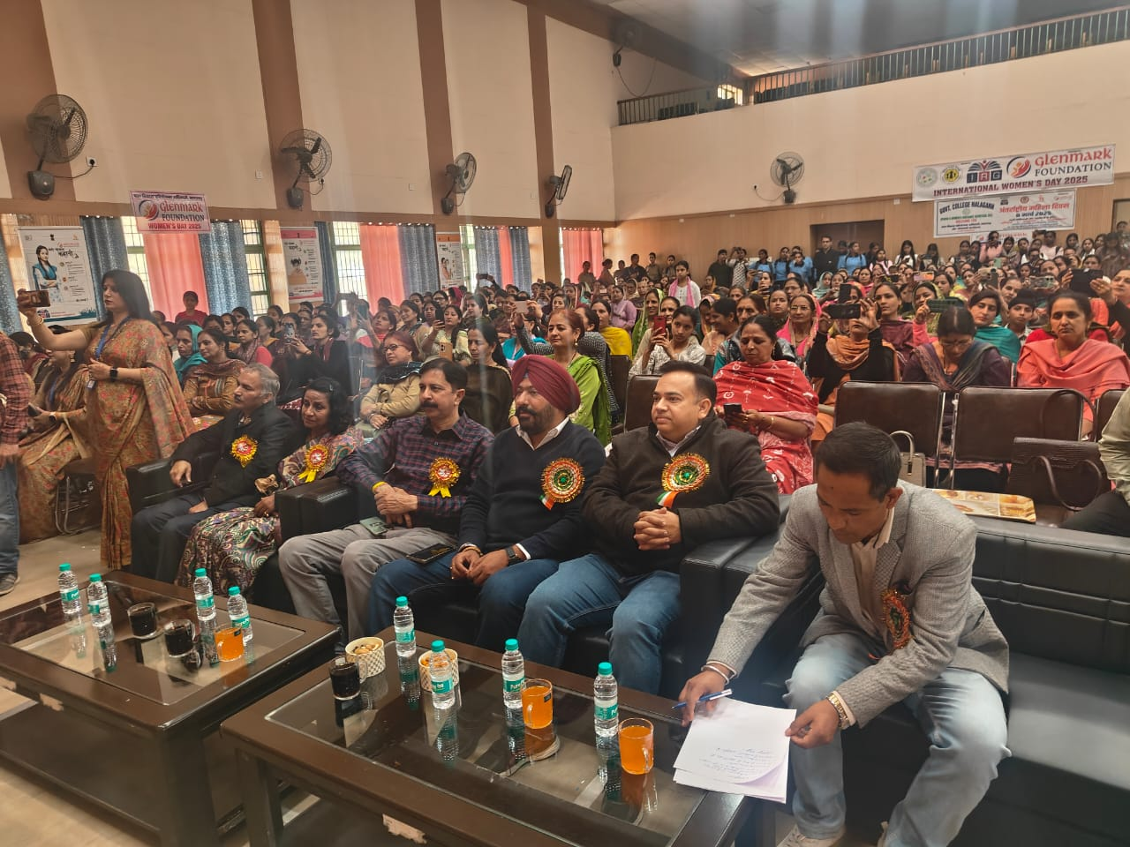
Picture 11. Two-Day Workshop on International Women’s Day

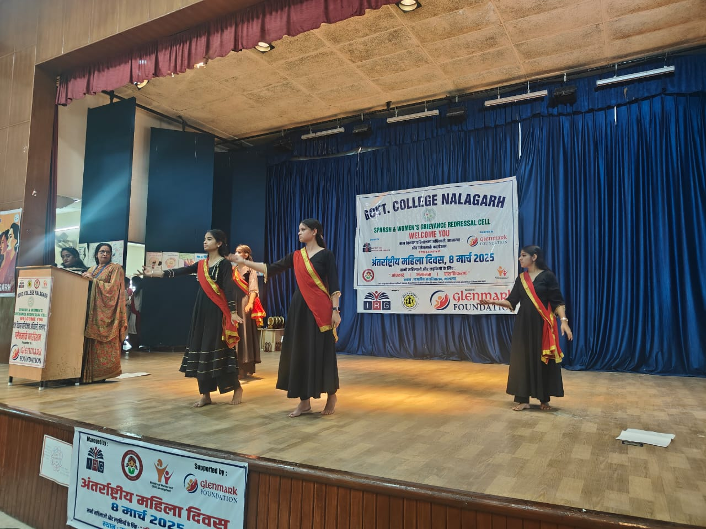
Picture 12. Two-Day Workshop on International Women’s Day
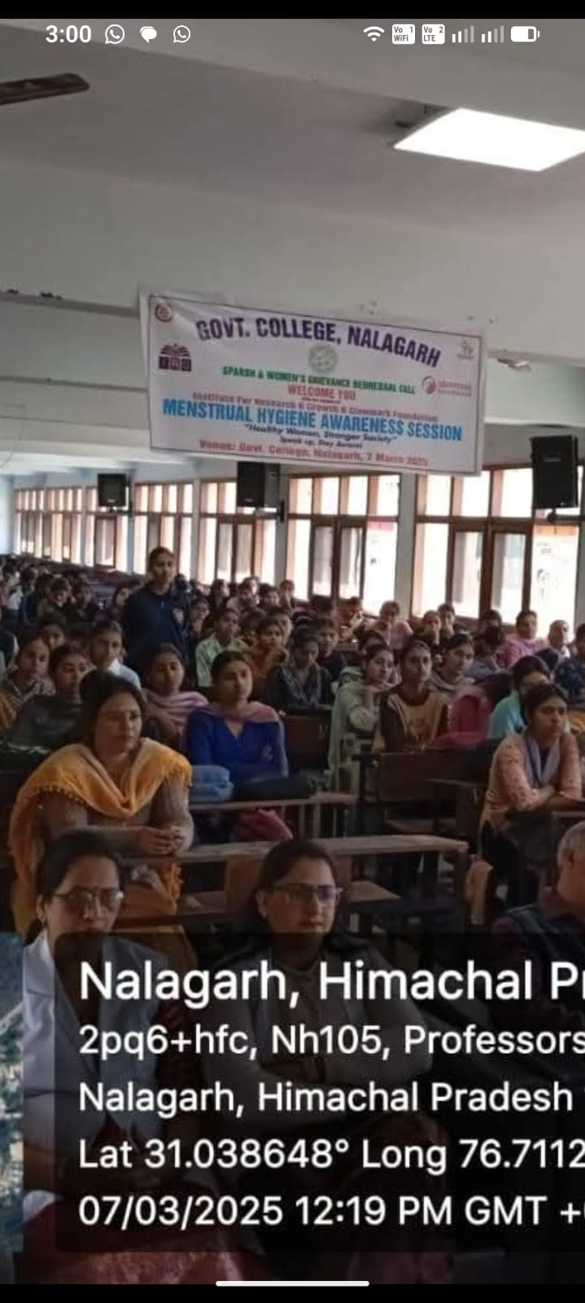
Picture 13. Lecture Organized on Menstural Health and Hygine Practices by Dr. Anjali
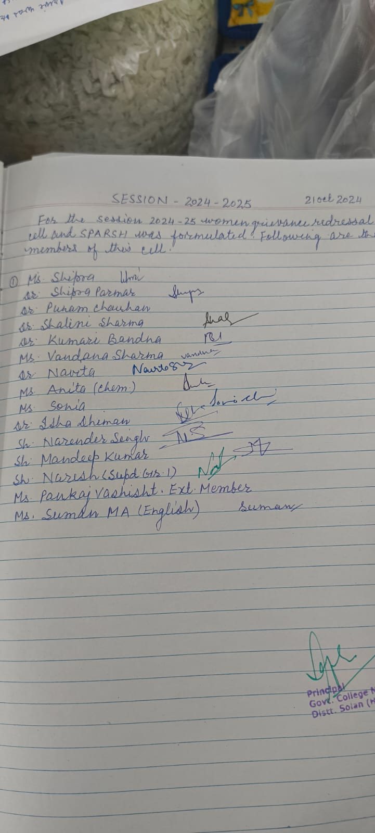

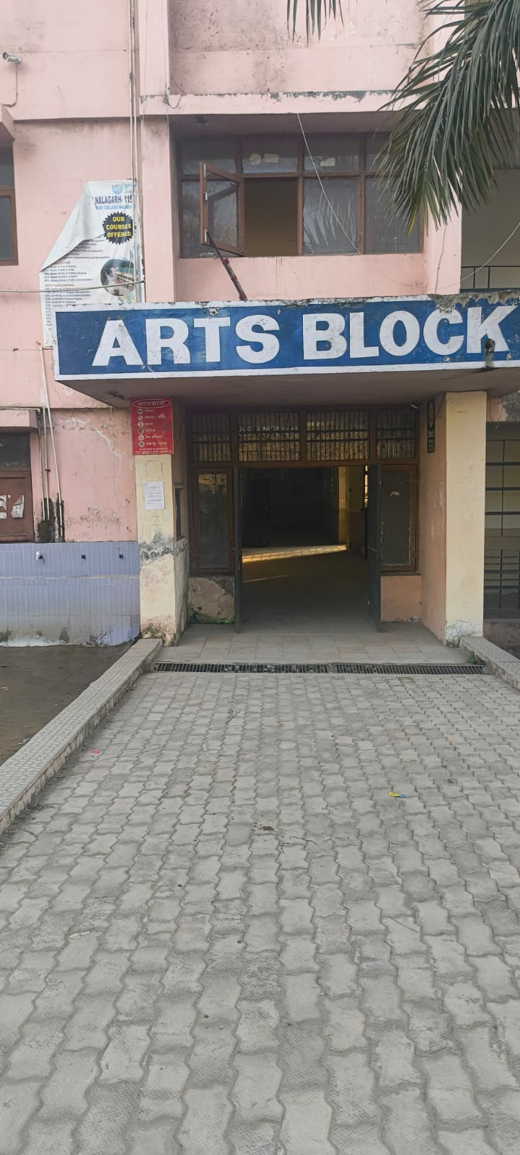
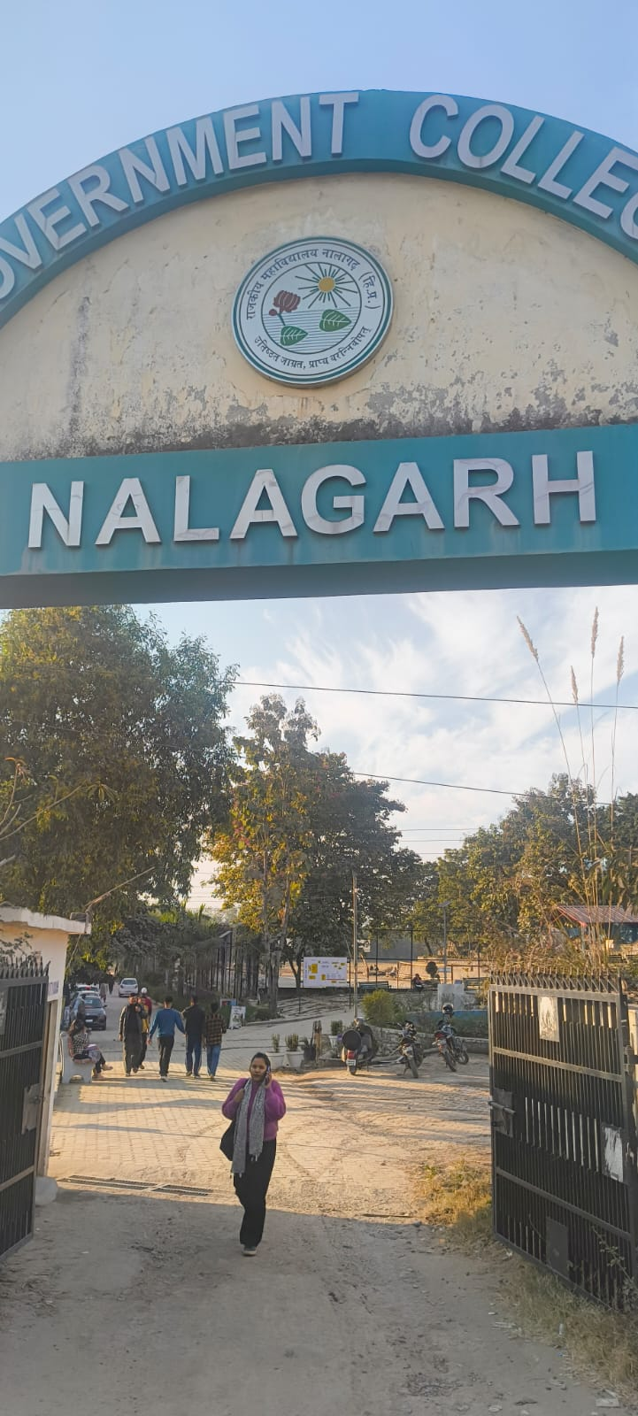
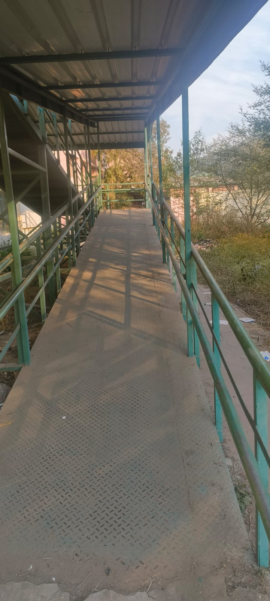
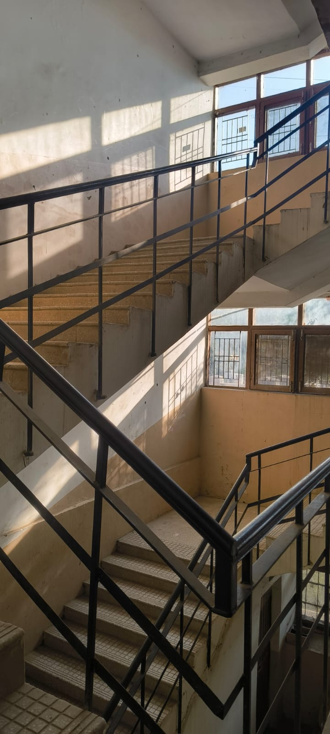
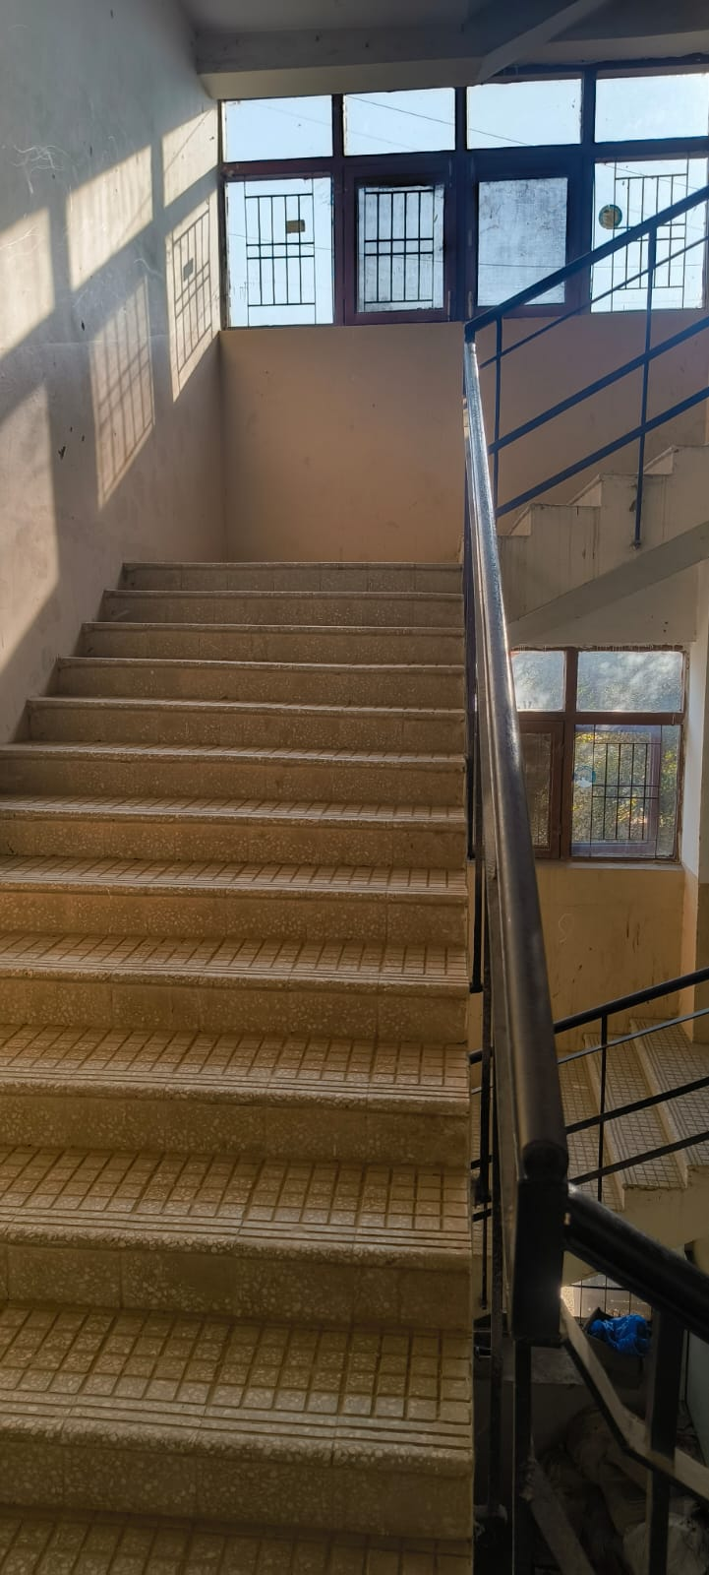
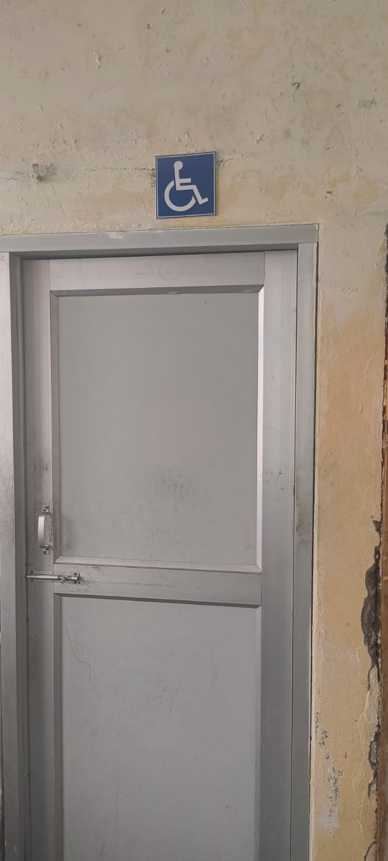

Ramps/Railings/Toilets

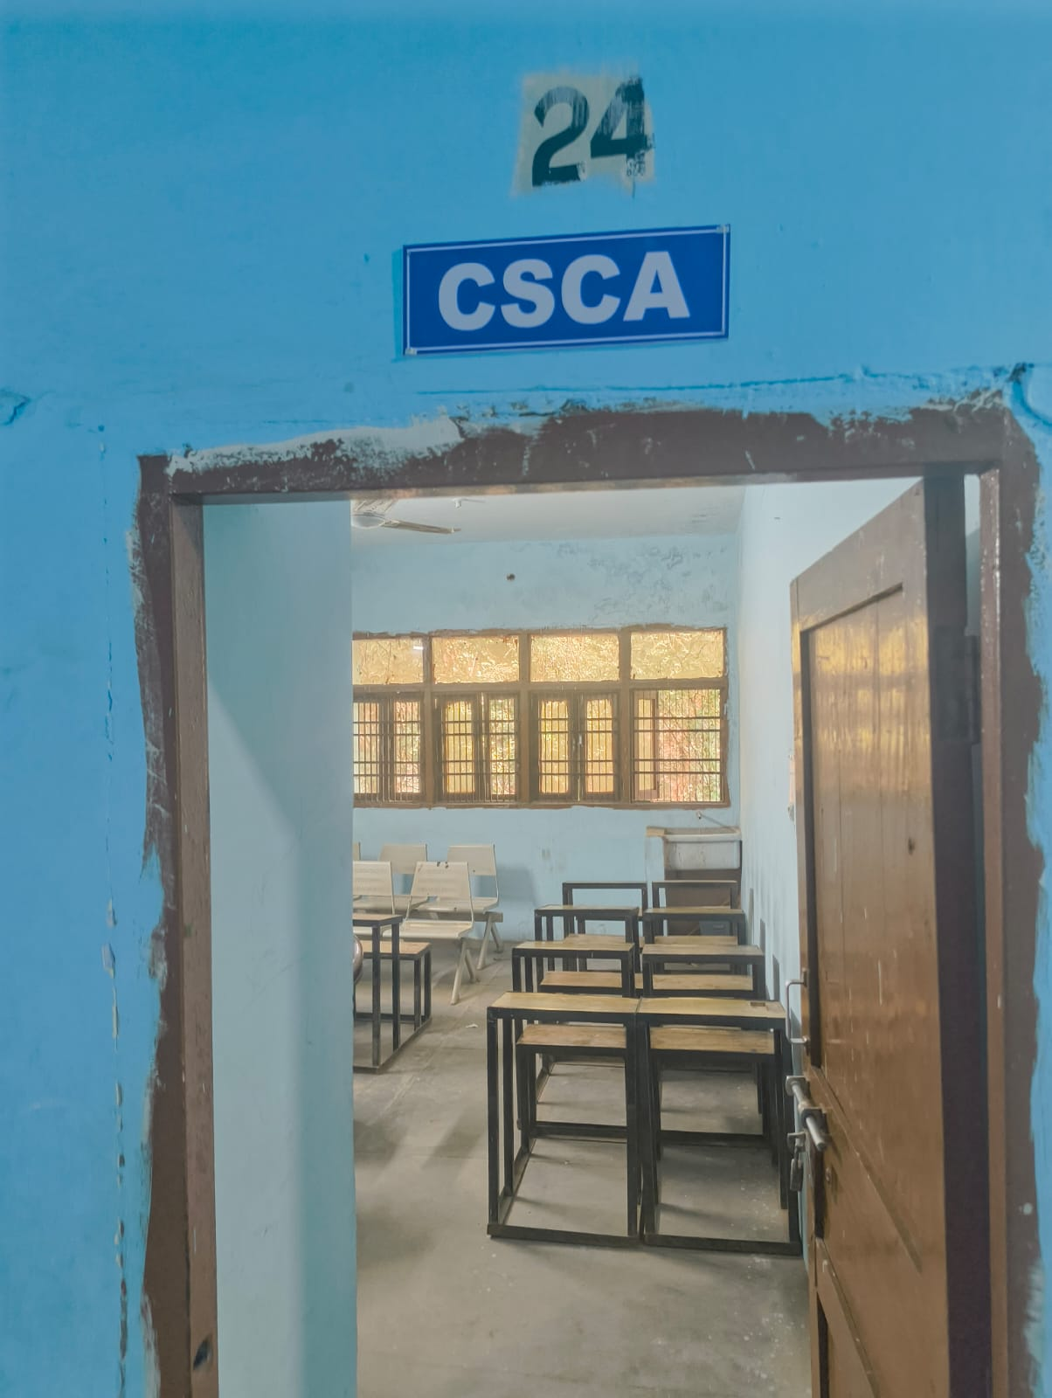
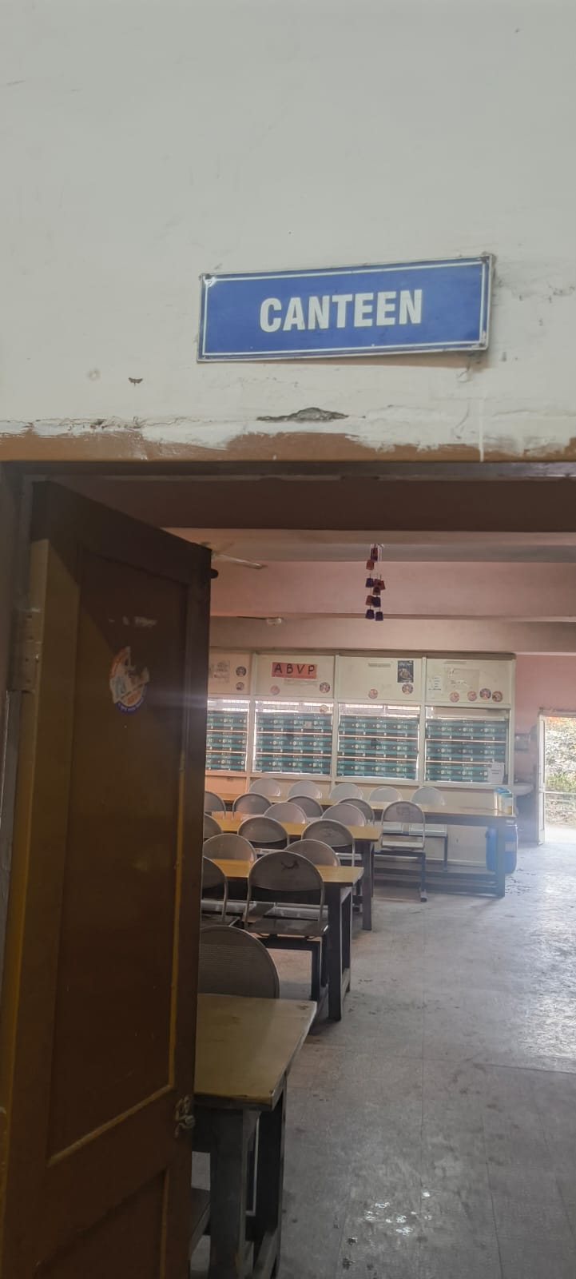
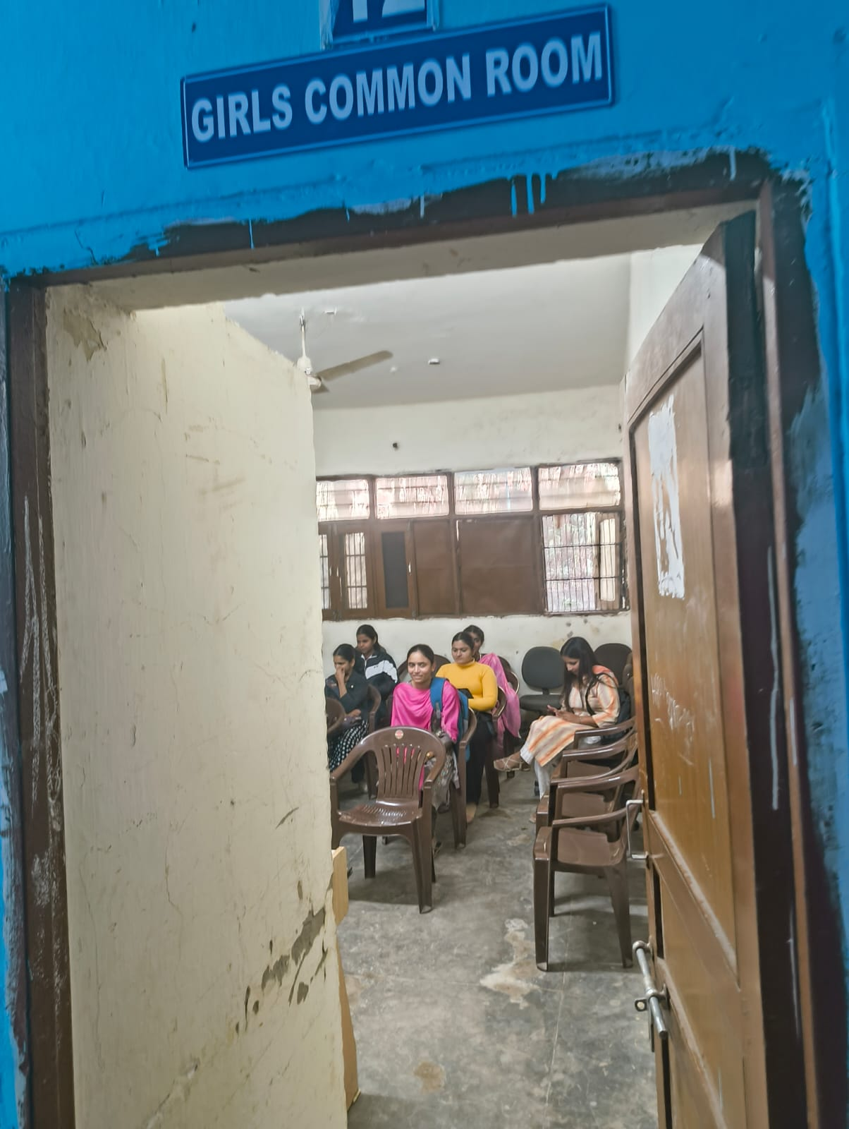
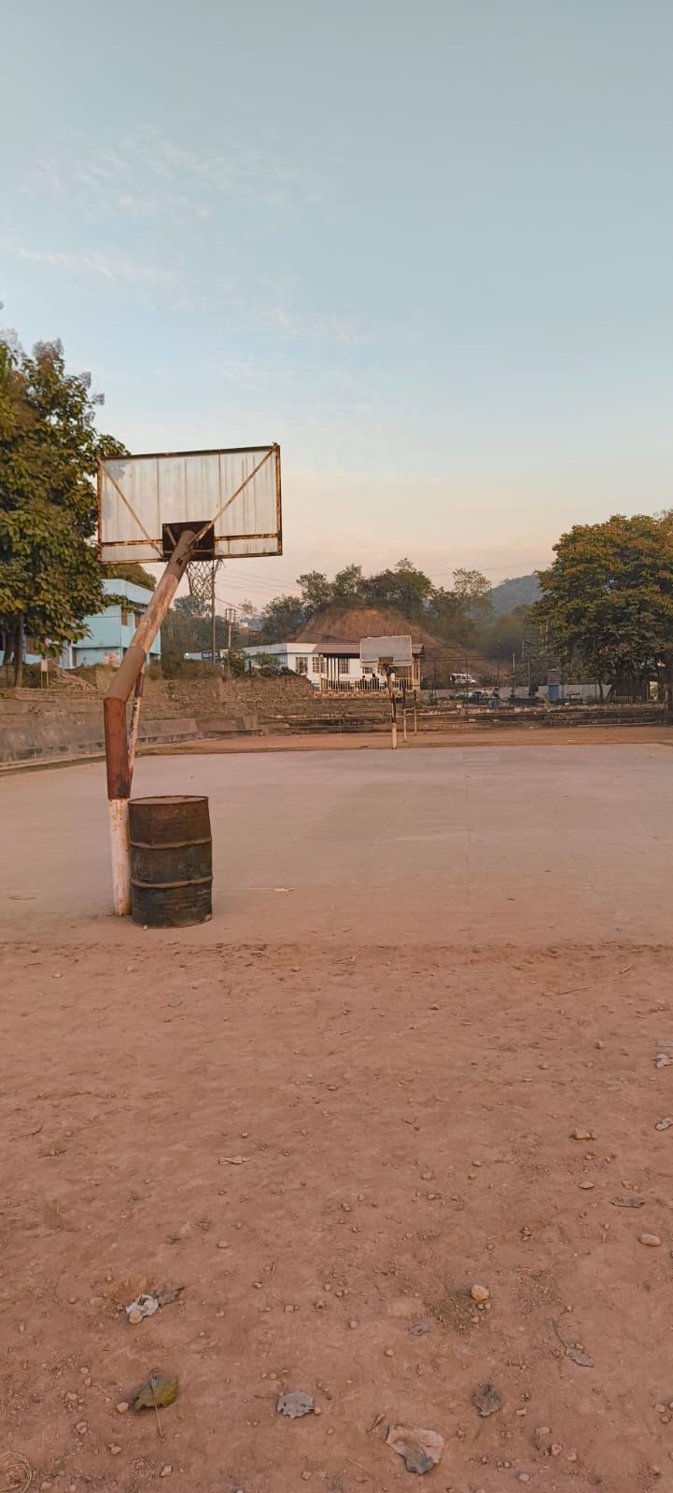
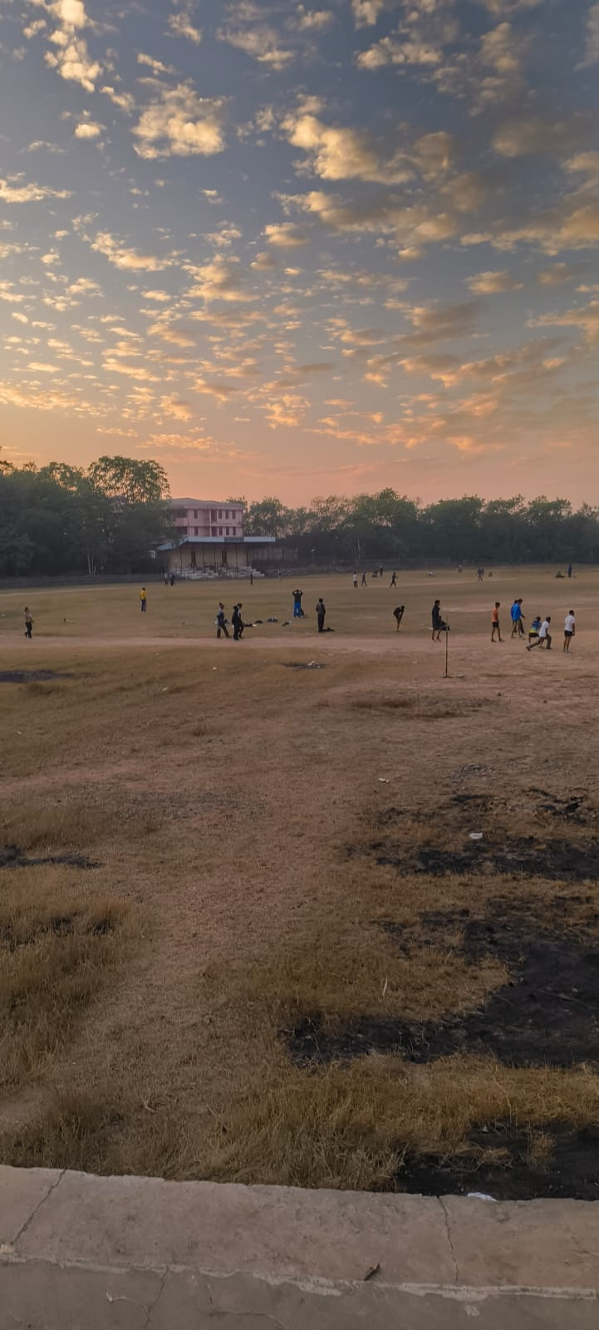
Facilities for Students

