Old Student’s Association (OSA)
Old Student’s Association (OSA) of Govt. College Nalagarh emerged in 2004 and registered in 2019 with registration number HPCD-1170. OSA has been actively involved in the overall development of the college by organizing various activities of social and developmental nature.
Government College Nalagarh is thrilled to announce its latest initiatives, showcasing its unwavering commitment to academic excellence, community engagement, and infrastructure development.Our esteemed alumni are the driving force behind our success. They're contributing generously to support their alma mater, making a tangible impact on our campus life. Our dedicated administration is committed to excellence, with regular meetings to support students' curricular and co-curricular activities. Government College Nalagarh is truly making waves with its commitment to excellence, community engagement, and infrastructure development.

- Open Stadium in front of Basketball Court: The OSA's 2024-25

The Old Students' Association (OSA) of Government College Nalagarh is on a mission to create an iconic Open Stadium, transforming the campus into a vibrant hub of sports, culture, and community spirit.

- Project Status: Partially completed, with the OSA's relentless efforts and community support driving it forward.
- The Challenge: PWD and similar agencies estimated the project cost at ₹20, 00,000+, but the OSA is targeting its completion in just ₹8,00,000, leveraging cost-effective strategies and community contributions.
- Funding: A big shoutout to the Truck Union, Nalagarh, for donating ₹3,00,000. The OSA is utilizing this contribution and using innovative, low-cost techniques to optimize resources. A proposal for additional funds is submitted and awaited.
- Execution: Waste material and low-cost strategies are being used to build a state-of-the-art stadium, demonstrating that excellence doesn't have to break the bank.
- Objectives:
- Create a modern Open Stadium that becomes the heart of campus life
- Strengthen the adjacent Science Block with structural support
- Tackle the long-standing issue of underground water seepage in the Basketball Court
- Impact: This project will elevate sports, cultural events, and community gatherings, making Government College Nalagarh a beacon of excellence.

The OSA's dedication and community support are driving this dream project forward, reflecting the college's commitment to holistic development and sustainability.
2. Blood Donation Camp: A Noble Cause
Old Students' Association, in collaboration with "Motorhood Detailers", Chowkiwala, and Our College, organized a Mega Blood Donation Camp. The event was a huge success, thanks to the enthusiasm and dedication of our students and staff. Dr. Harvinder Singh, Dr. Naresh Kumar, and other college teachers donated blood, setting an example for others to follow.The event saw a tremendous response from students, staff, and the local community, highlighting the importance of blood donation in saving lives.
3. Power Lifting National Championship, Agra: ₹5,000 supported Suraj Kumar's national-level achievement, securing 3rd prize.
4. Donation forAnnual Prize Distribution: ₹21,000 to inspire and reward excellence.
5. Blood Donation Camp: Old Students' Association, in collaboration with "Motorhood Detailers", Chowkiwala

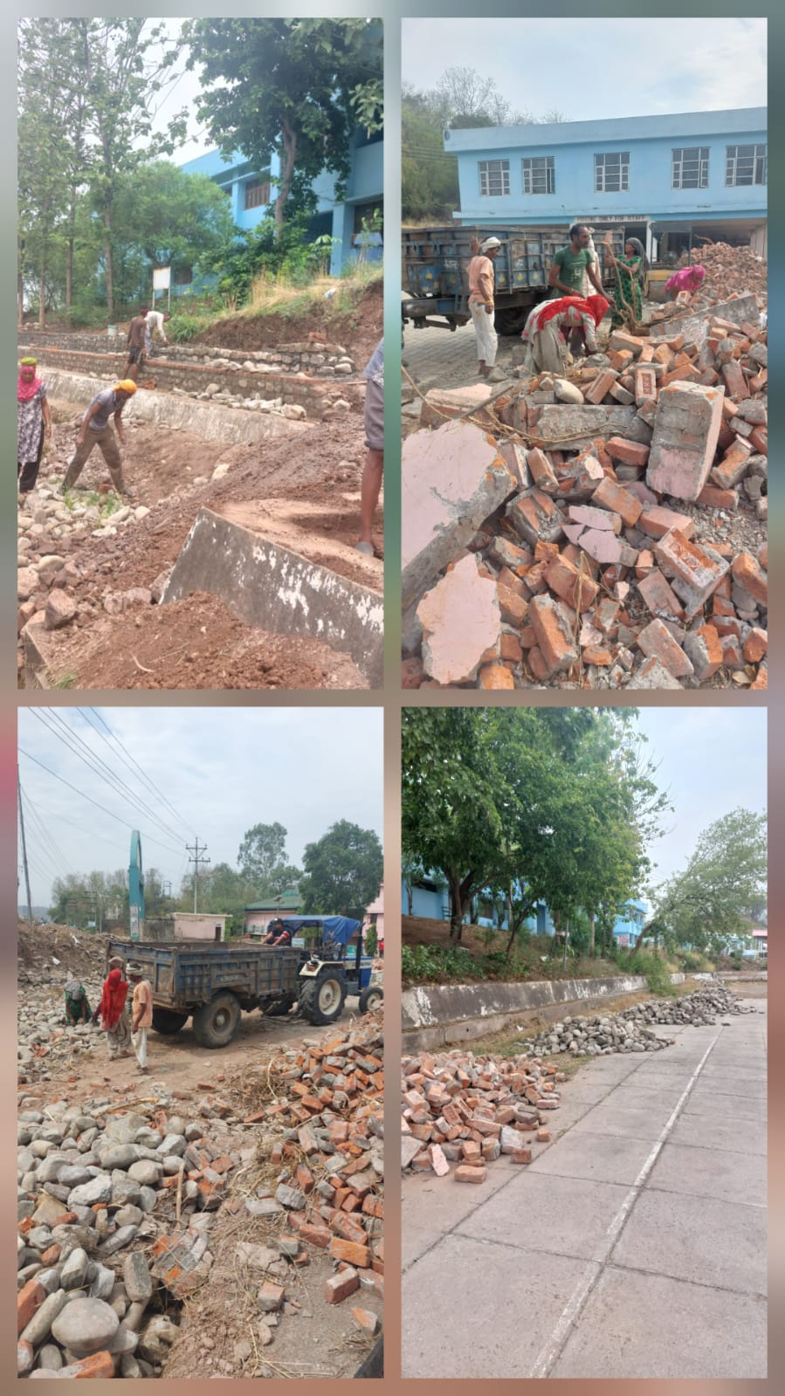
Waste to Best- Construction of Open Stadium by OSA in front of Basketball Court

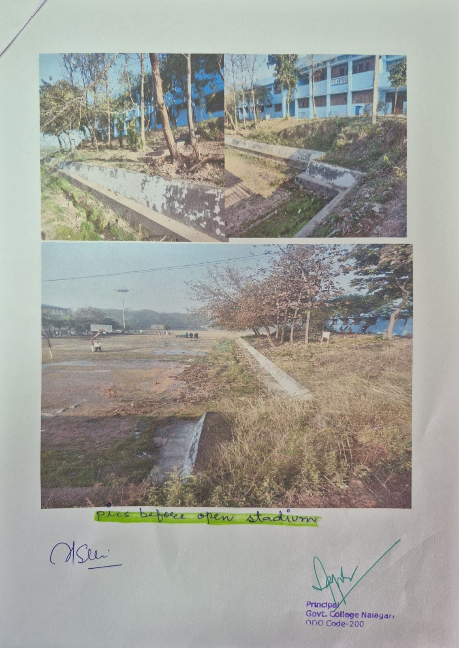
Waste to Best- Construction of Open Stadium by OSA in front of Basketball Court

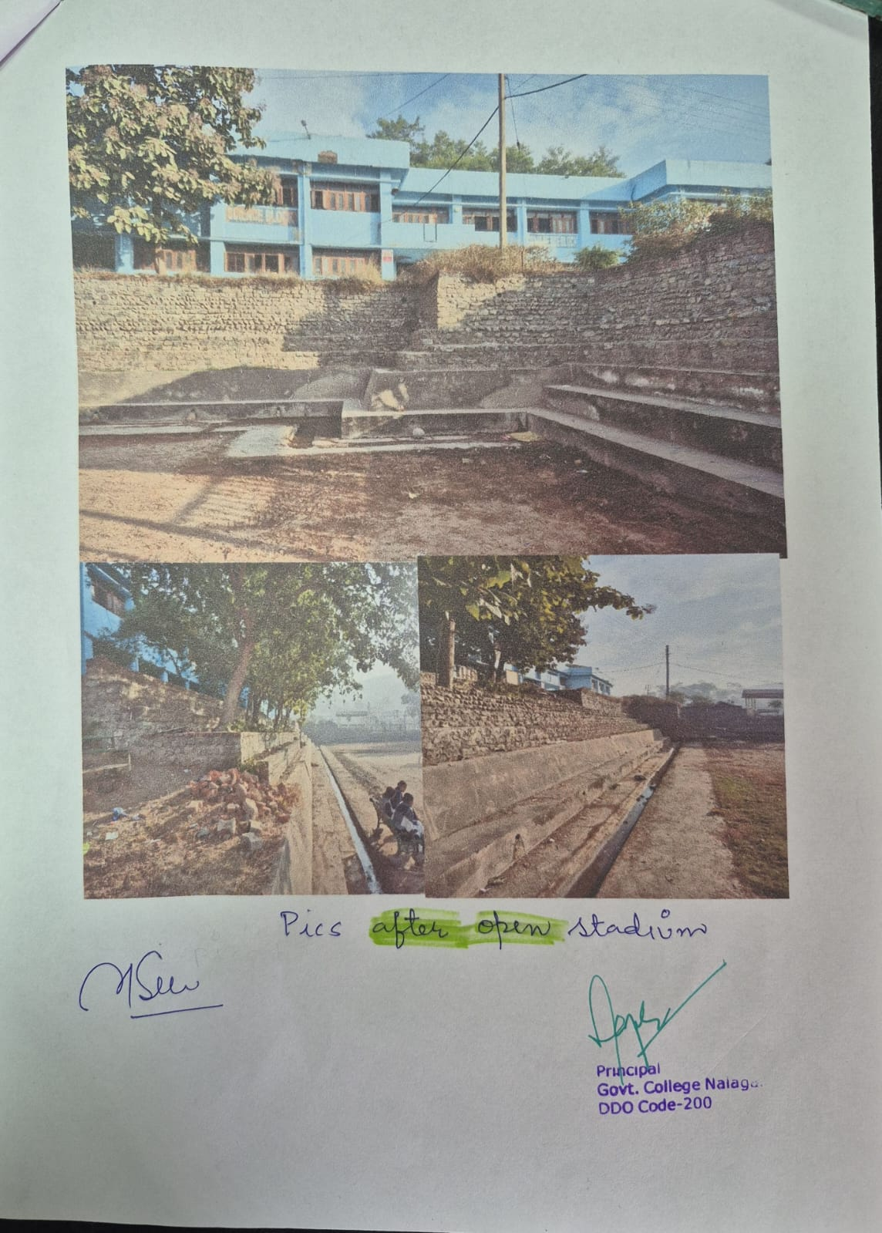
Waste to Best- Construction of Open Stadium by OSA in front of Basketball Court

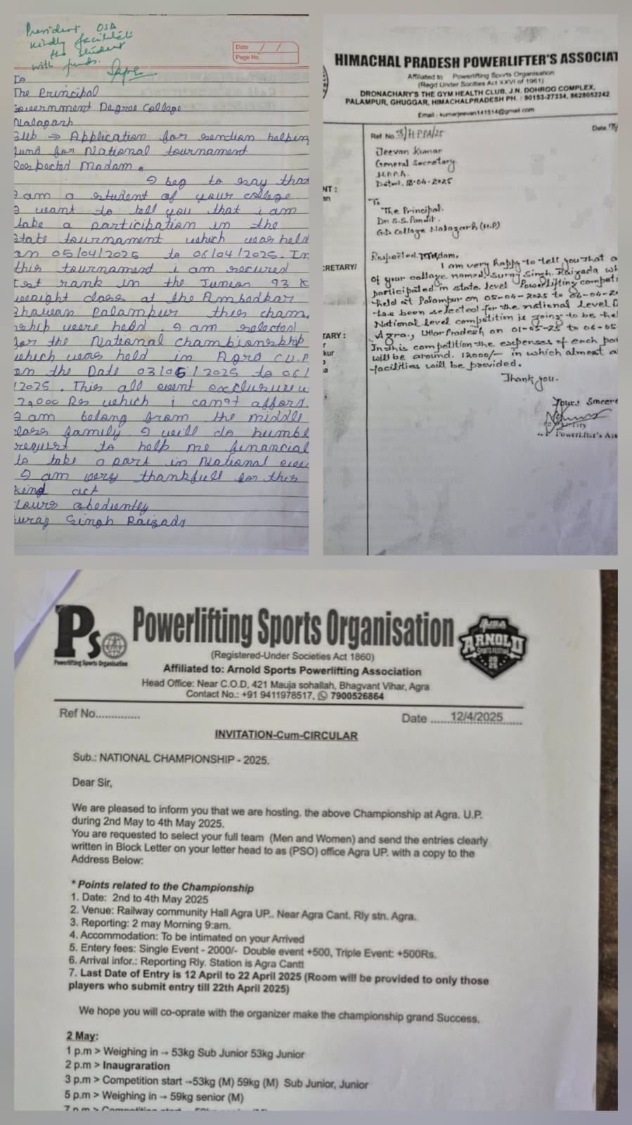
Power Lifting National Championship, Agra: ₹5,000 supported Suraj Kumar's national-level achievement, securing 3rd prize.

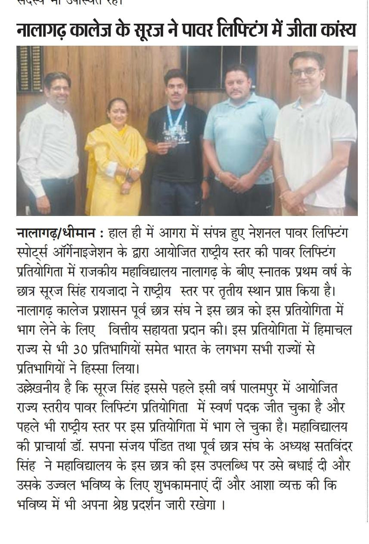
Power Lifting National Championship, Agra: ₹5,000 supported Suraj Kumar's national-level achievement, securing 3rd prize.
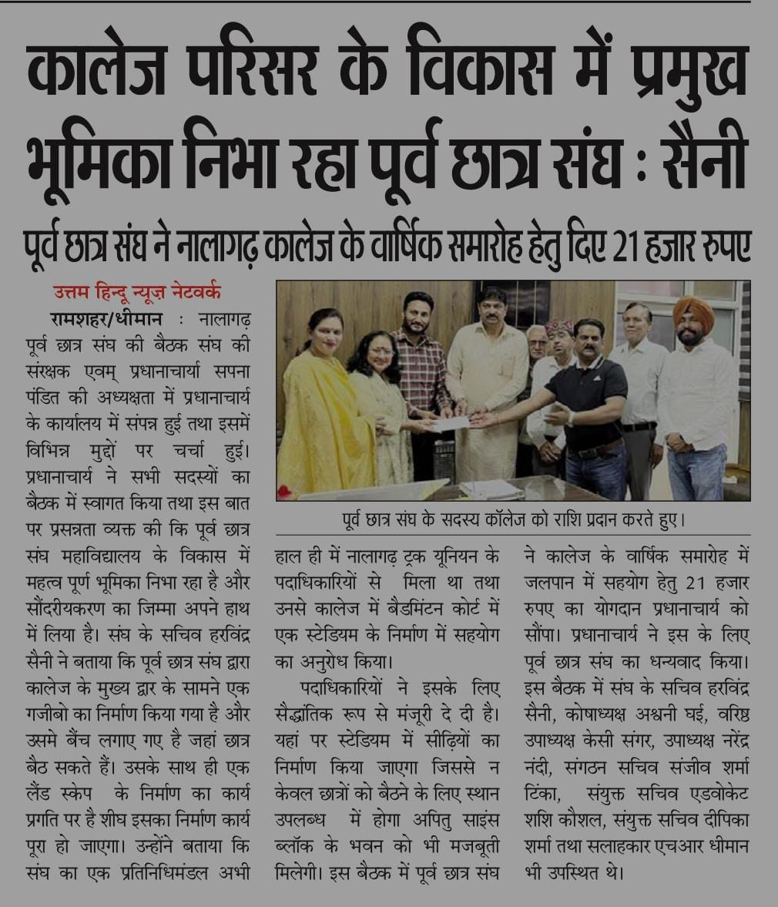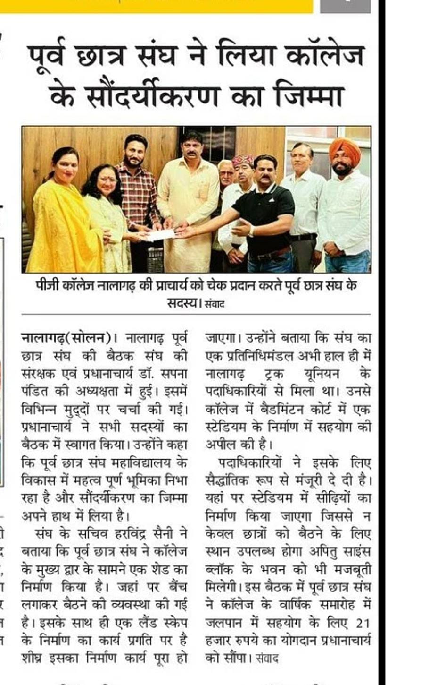
Donation forAnnual Prize Distribution: ₹21,000 to inspire and reward excellence

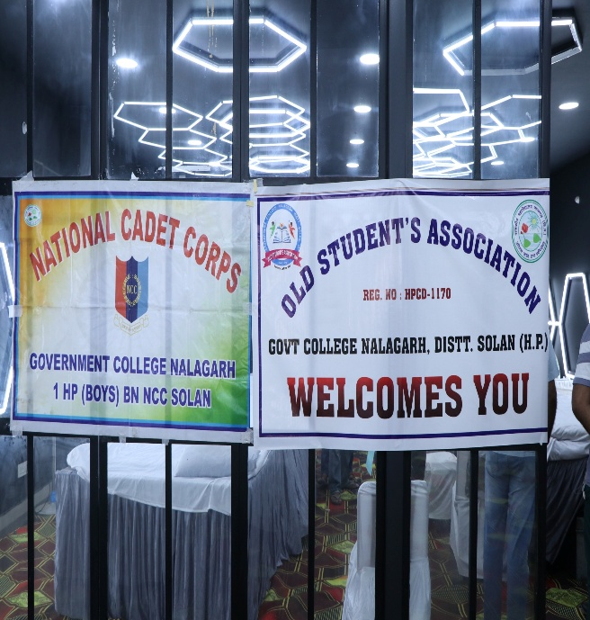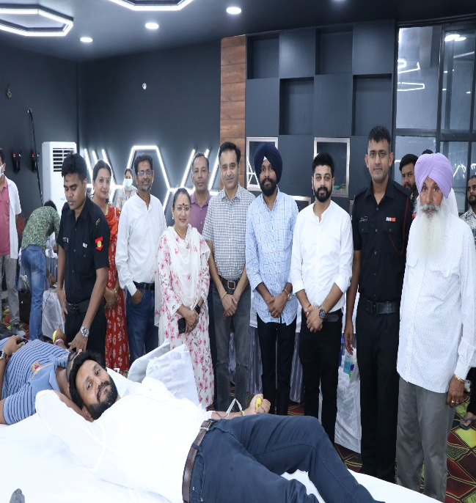

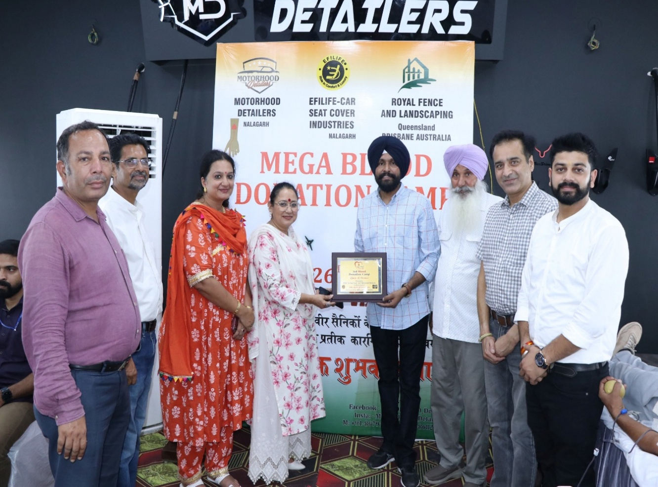

Blood Donation Camp: Old Students' Association, in collaboration with "Motorhood Detailers", Chowkiwala

