Green Audit Report
2024 – 2025
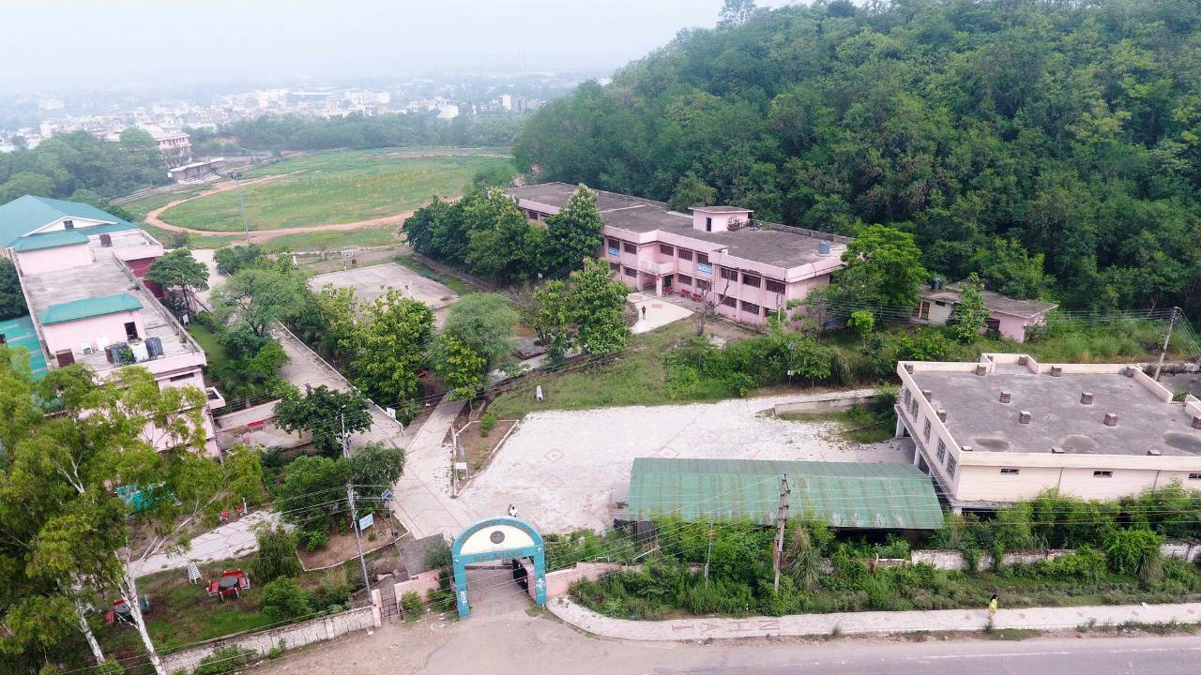

GOVERNMENT POST GRADUATE COLLEGE
Nalagarh, District Solan (Himachal Pradesh)
- INTRODUCTION
A Green Audit systematically evaluates the total environmental impact resulting from an organization's activities and practices. This process analyzes existing operations against current environmental laws. It assesses the nature and availability of resources, scrutinizes utilization patterns, and determines the resulting impact on environmental components. The audit considers all activities that affect the environment positively or negatively. It functions as a vital environmental management monitoring tool, leading to the identification of areas for improving health, safety, and work quality. The audit ensures development while safeguarding the environment, often fostering efficient and cost-effective management methods. The recommendations in the Green Audit Report are essential for institutions to devise future strategies and ensure environmental sustainability
- OVERVIEW OF THE COLLEGE:
Right from its inception in 1973 to the present time now the college can boast of one of the largest campuses (30 acres) in Himachal Pradesh. The college got its first building, presently designated as Science and Commerce block (Old Block) in 1991 and the establishment shifted from the palace to this one. Rapid growth of the college made it imperative for the college to create additional built – up space, so a new imposing structure was built in 1997 which now houses the Multipurpose Hall, Administrative offices, classrooms, library, canteen, few department‘s rooms, NCC (girls) office, two big halls, staff room, seminar hall, IGNOU room, computer labs and stores. Government PG College, Nalagarh has done the first cycle of assessment and accreditation from National Assessment and Accreditation Council (NAAC) in 2016. The NAAC emphasizes on conducting of green audit in the institutions. So, the College has initiated this practice of conducting the green audit in order to analyze the current environmental set up and assess the green initiatives being taken by the College and further strengthen them.
- METHODOLOGY

  - Site Surveys: Physical inspections were performed across the campus to assess existing environmental infrastructure. This included evaluations of green areas, the functionality of the rainwater harvesting system, the structural integrity of the check dam, and the operational status of solar panel installations.
  - Data Collection: Primary data was systematically gathered through interviews with key institutional stakeholders, specifically faculty members, the Eco Club, and relevant representatives from municipal waste authorities. This step provided crucial qualitative and quantitative operational data.
  - Geospatial Analysis: Geographic Information Systems (GIS) and satellite imagery were employed for accurate geospatial mapping of the campus. This allowed for precise quantification of green areas and the effective spatial representation of energy infrastructure, such as solar panel installations.
  - Community Engagement: To gauge institutional awareness and participation, a focused survey was conducted among students and staff. The goal was to assess the level of engagement in established environmental initiatives, such as the annual Van Mahotsav tree-planting drive, providing insights into the College's environmental culture.

Geographical location, Design of the building, Natural Lighting and Ventilation
- The College is situated on outskirts of Nalagarh town (31°03′N 76°43′E﻿ / ﻿31.05°N 76.72°E﻿ / 31.05; 76.72), of Solan District of Himachal Pradesh.
- The Nalagarh is located in the foothills of Shiwalik range at an altitude of 348m and is a transition zone between plains and high mountains.
- The major part of campus is open and under green cover. Some open area is being further developed into parking area, vermicompost area and for enhancement of green cover. The work for the Botanical Garden is going on at present and is expected to be complete in the next academic year.
- The building is on the side of side of National Highway number 105. No structure hinders the light or wind/ air flow of College campus. There is green topography with mixed vegetation and low inhabitation in the surroundings.
- The Built up structures of college include three blocks (Science Block, Arts Block, Multipurpose hall, Girls’ and Boys’ hostels, Staff quarters, Lawn Tennis Courts, and Playground).
- There is a playground in front of Administrative block. However it is small and inadequate for many outdoor games. The efforts have been made by College authorities in this regard and as a result the announcement for expansion and further development of playground has been made by Govt. recently. At own level also, the College is undertaking the small expansion and development activity.
- The Baddi-Barotiwala-Nalagarh (BBN) industrial area has profoundly impacted Government College Nalagarh, particularly concerning green spaces and pollution. While industrial growth has boosted local economies and created job opportunities for students, it has also led to significant environmental challenges.
- Increased industrial activity can contribute to air and water pollution, which poses health risks and negatively impacts the overall quality of life in the region. This pollution can hinder students' well-being and academic performance, leading to concerns about environmental sustainability. Recognizing these challenges, the college has the opportunity to integrate environmental education into its curriculum, emphasizing the importance of sustainability and pollution mitigation.

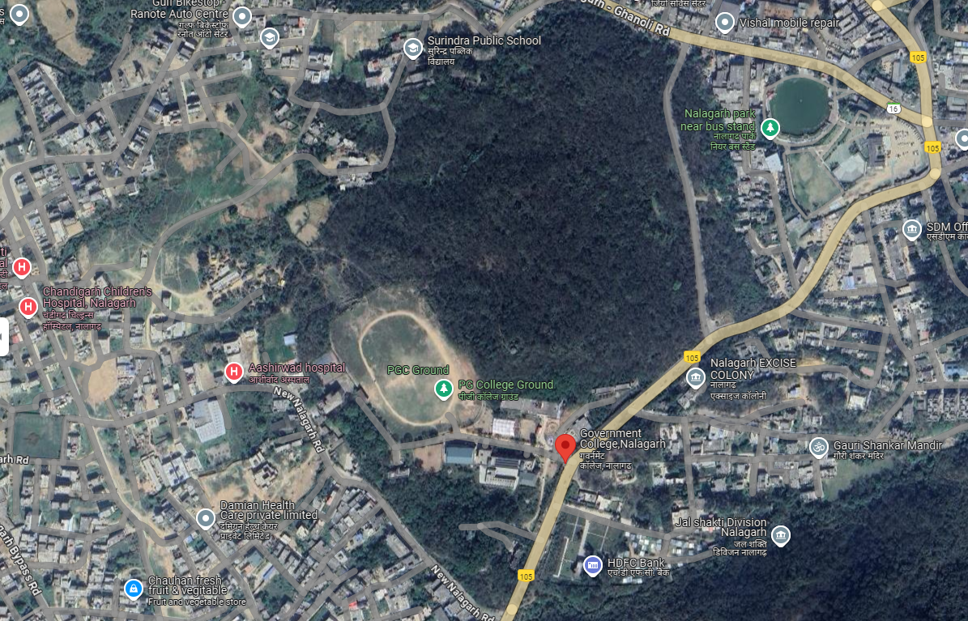Satellite View of the College (Source: Google maps)

- The presence of lush greenery, trees, and wildlife creates a serene and calming atmosphere that helps students to concentrate and focus on their academic pursuits. The natural surroundings provide a welcome respite from the hustle and bustle of city life, allowing students to recharge and rejuvenate their minds and bodies. The proximity to nature also offers numerous opportunities for outdoor activities, which not only promote physical fitness but also foster a sense of community among students.
- In such a setting, students can immerse themselves in the beauty of the natural world, gaining a deep appreciation for the environment and the need to protect it for future generations. Campus surrounded by nature is truly a unique and special place, offering a one-of-a-kind educational experience that enriches the mind, body, and soul.
Environmental Parameters Evaluated
Total Green Area of the College
The college prides itself on having over 70% out of 30 Acres of its campus area covered in green space, offering a serene environment conducive to learning.

Green Area Statistics:
- Campus Size: 30 acres.
- Green Area: More than 70% (approximately) covered by trees, shrubs, and playground.
- Plant Diversity: Includes a rich variety of local species like Monoon longifolium, Acaciacatechu,Albizzia lebbek, Caesalpinia decapetala, Lantana camara, Terminalia balerica, Cassia fistula, Toona serrata, Butea monosperma, Lagerstroemia parviflor, Syzygium cumini, Bauhiniavariegata,Mallotus philippinensis,Zizyphus mauritiana,Ficus religiosa, Azadirachta indica; Ornamental, Aromatic and medicinal plants used for educational purposes.
Ongoing Efforts for Plantation Drives:
- Annual Tree Plantation Drives: The Eco Club organizes plantation drives during the monsoon, as part of the Van Mahotsav celebrations, to increase tree coverage.
- Awareness Campaigns: The Eco Club, Rovers and Rangers, NSS, NCC regularly conducts workshops on sustainability, energy conservation, plantation drives, and waste management.
- Landscaping: The ongoing landscaping efforts aim to create visually appealing, functional, and sustainable spaces, utilizing native flora to promote biodiversity.
- Van Mahotsav (July): The college celebrates Van Mahotsav annually, a tree-planting festival held during the monsoon season, organized by the Eco Club. Students and staff actively participate in planting hundreds of saplings to contribute to the green cover of the campus.
- Post-Monsoon Plantation: Additional planting occurs in October to ensure the survival of plants through the winter.
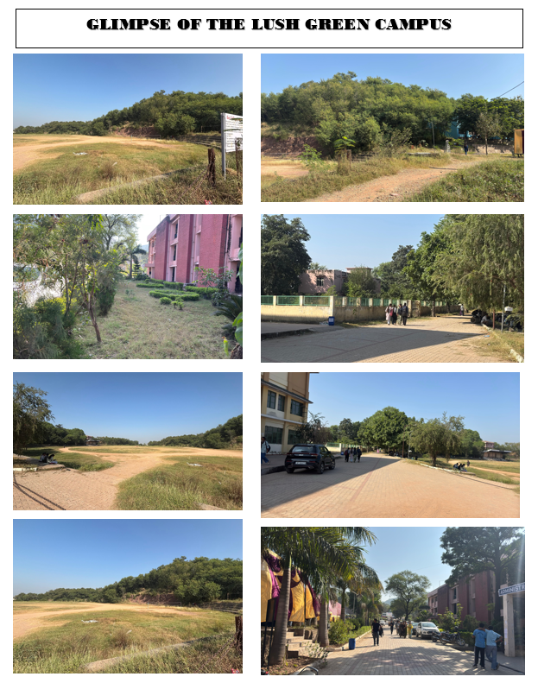

Maintenance Practices:
- There are two gardeners working in the campus round the clock to maintain the plants and greenery.
- Irrigation Systems: Taps are placed across the garden and landscape area to efficiently water the plants and trees.
- Use of Organic Compost: The college has a vermicompost pit where organic waste is processed into nutrient-rich compost, which is used in the campus gardens.
Pollution Sources and Control Measures
Pollution control is a significant aspect of the college's sustainability goals.
Pollution Sources:
- Air Pollution: Primarily from Industry and vehicles on the national highway and entering the campus.
- Solid Waste: Mostly non-biodegradable waste such as plastic and food packaging from the canteen.
Control Measures:
- Green Barriers: Rows of trees along the perimeter help reduce dust and vehicular pollution.
- Solid Waste Collection: The local municipal committee is responsible for collecting non-biodegradable solid waste from the campus. Biodegradable waste is processed in the vermicompost pit.
- Eco-Friendly Initiatives: Campaigns by the Eco Club promote reducing plastic use and opting for eco-friendly alternatives like reusable containers.
- Use of Dust Bins: Dust bins are placed in every nook and corner of the college to maintain cleanliness and to avoid littering of garbage.
Water Resource Management
Water Conservation Techniques:
- Rainwater Harvesting: The rooftop rainwater harvesting system collects rainwater from building rooftops, storing it in underground tank, which is then used for watering the gardens and non-potable purposes. Storage capacity of the tank is about 50,000 liters, sufficient to meet a significant portion of the campus's water needs.
- Check Dam: The College has constructed a check dam on the one end of playground of the campus to tap rainwater and to reduce soil erosion. This small water-holding structure helps capture runoff during the monsoon, prevents soil erosion, and recharges the groundwater table. It helps in collecting runoff during heavy rains and provides a year-round water source for irrigation and other purposes. The check dam enhances water retention in the soil and helps recharge nearby groundwater levels, contributing to long-term water sustainability for the college.
Water Utilization:
- Irrigation: Water from both the check dam and the rainwater harvesting system is utilized for irrigation of the green areas.
- Sanitation: Rainwater is also used in toilets, reducing reliance on external water sources.
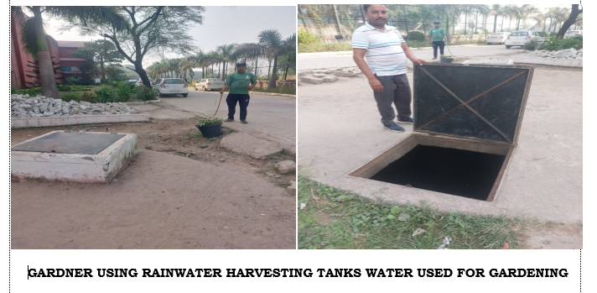
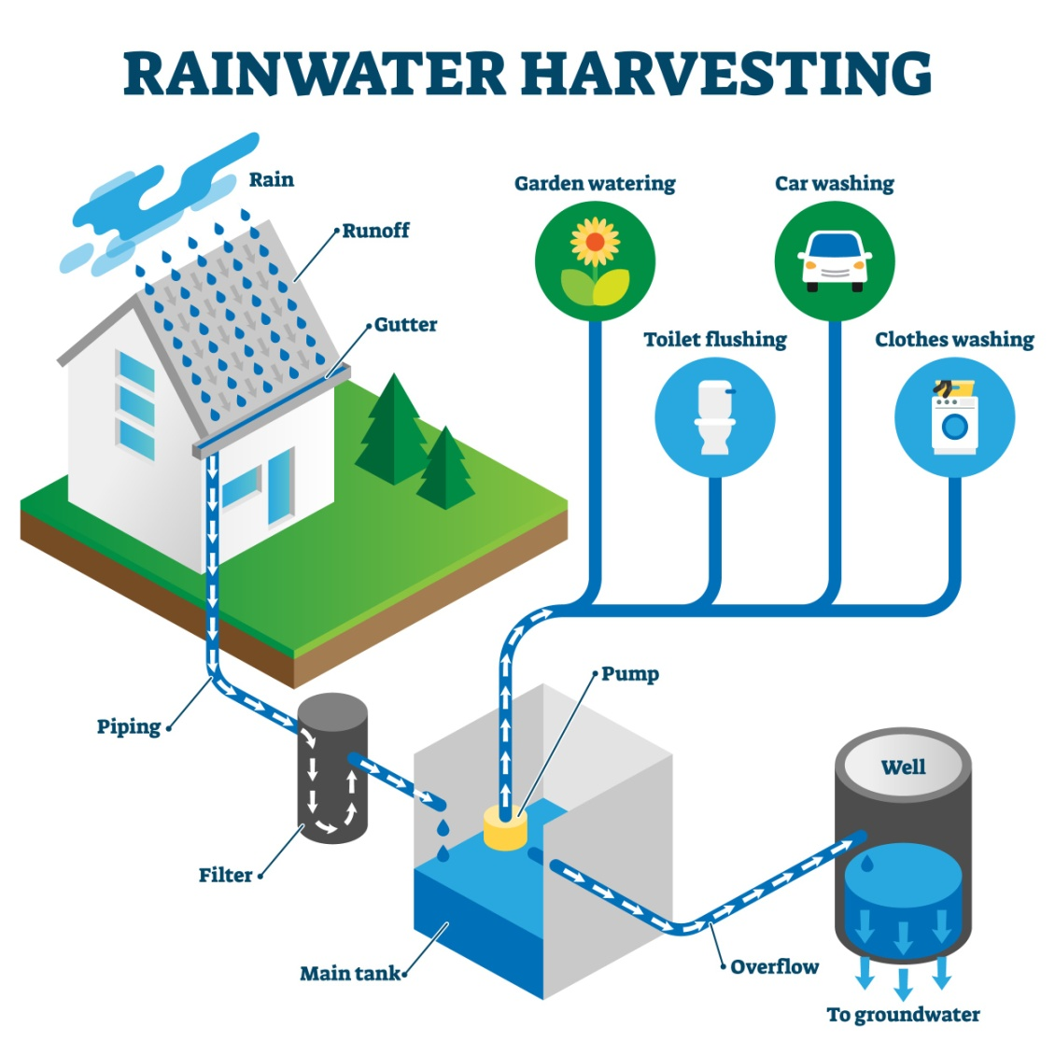
Solar Energy Initiatives and Sustainability
The college has a functioning solar panel system contributing to its energy needs.
Solar Energy Infrastructure:
- Installed Capacity: Capacity of about 35 kW of solar panels have been installed on the rooftops of the academic buildings.
- Electricity Production: The solar panels generate approximately 600 units of electricity per month, which is used to power classrooms, administrative offices, and outdoor lighting systems.
- Contribution to Energy Needs: The solar energy system reduces the reliance on grid electricity by 50%, making the campus more sustainable.

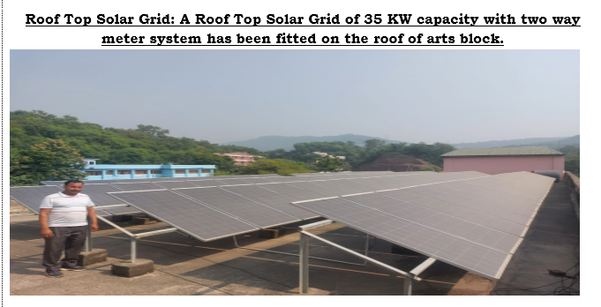
ENERGY CONSERVATION AND USE OF SOLAR ENERGY
- Solar lights: There are total 20 Solar Lights in the college which illuminates the campus during night time.
- Roof Top Solar Grid: A Roof Top Solar Grid of 35 KW capacity with two way meter system has been fitted on the roof of arts block.
- LED lights: Every classroom, corridors and office are fitted with LED lights.

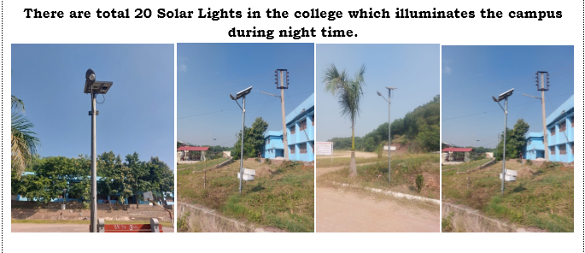
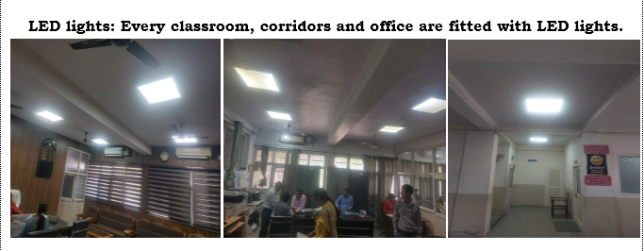
Solid Waste Segregation and Management
Different kind of waste is generated in the college campus on the daily basis. The main source of waste generation is college canteen, where the solid waste in the form of vegetable wastes, tea leaves, cooked food waste, bottles, tetra packs, wrappers, tins, plastics, metal, glass etc. The college office also generates paper waste. Waste is also generated in the campus as fallen leaves. Following measures have been taken at college to manage the solid waste.
Adoption of 3 R approach viz. reduce, reuse and recycle.
- Waste segregation: There are separate dustbins installed for the biodegradable and non biodegradable waste in the campus.
- Composting of recyclable waste: Upon segregation the biodegradable waste like vegetable wastes, tea leaves, tree leaves, cooked food waste are shifted to the compost pit in the herbal garden.
- The waste paper is reused from reverse side in the midterm exams.
- The bottles, tins, plastics, metal, glass etc., are collected by kwariwala every weekend.
- Creation of landfill site: A landfill site is created in the college campus where non-biodegradable solid waste is dumped.
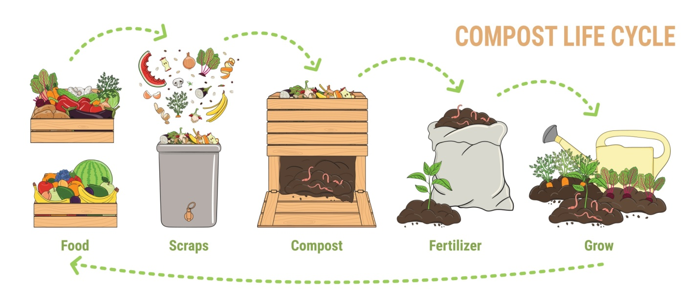

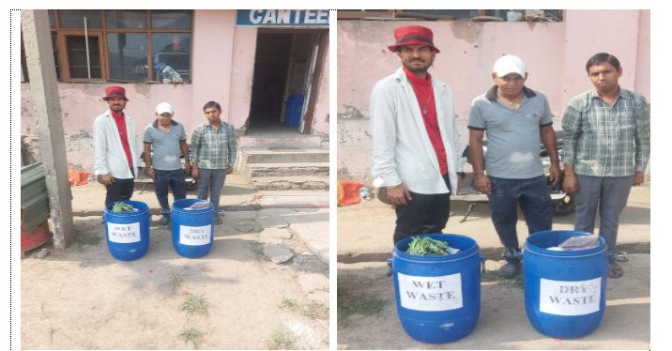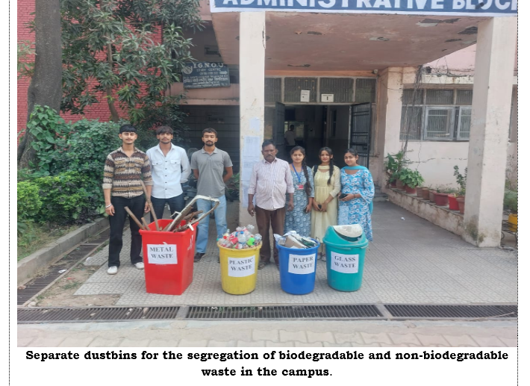
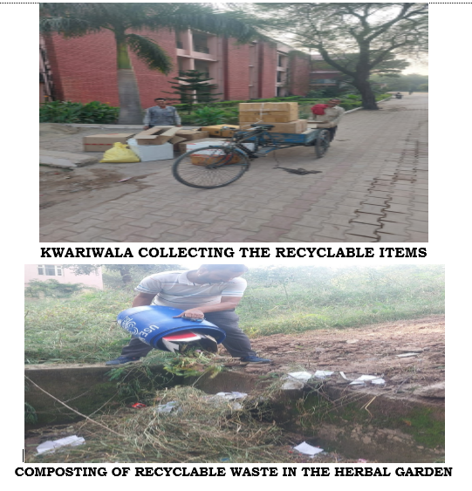

Green Initiatives Undertaken
Botanical Garden in Pipeline:
- Current Status: The College is in the process of developing a botanical garden that will serve as a center for both academic study and biodiversity conservation.
- Objective: The garden will feature a collection of native plant species, medicinal plants, and endangered species, contributing to both environmental education and biodiversity conservation.
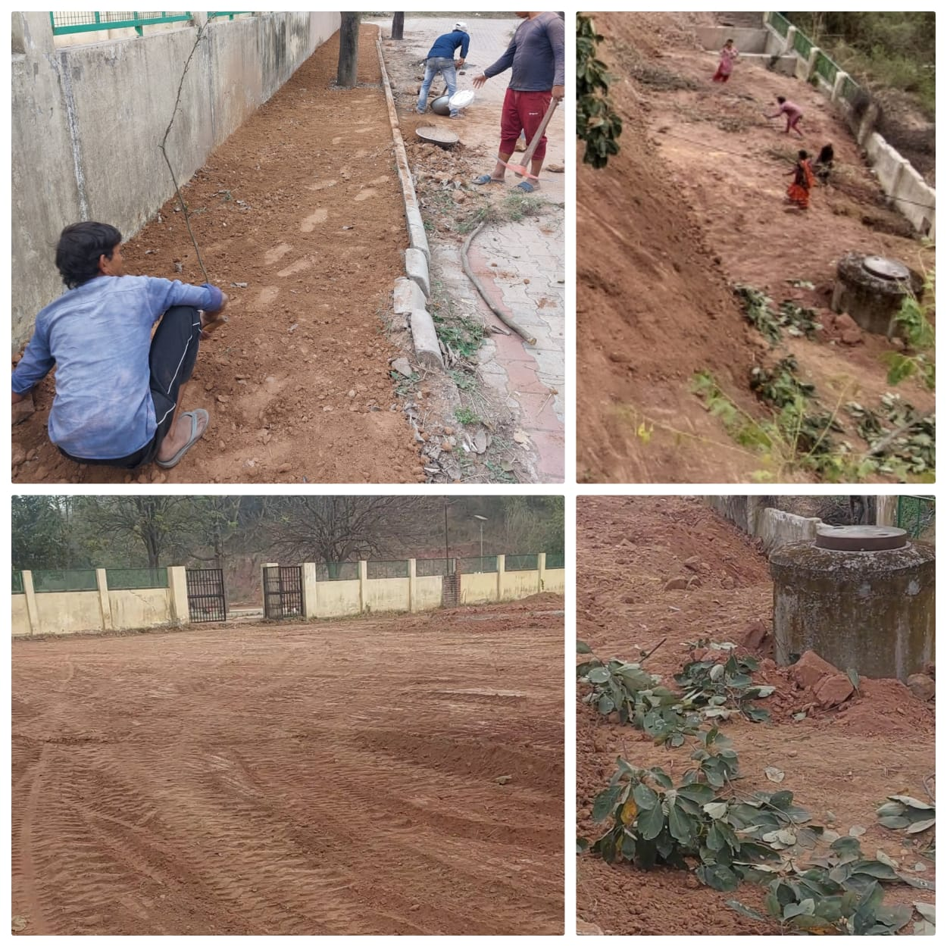
WORK IS UNDERWAY TO ESTABLISH BOTANICAL GRADEN
Vermicomposting Pit:
- Location: A designated vermicomposting pit has been established on the campus to process organic waste.
- Usage: Organic waste generated from gardens and canteens is composted, producing high-quality manure used for nurturing plants and trees in the green areas.
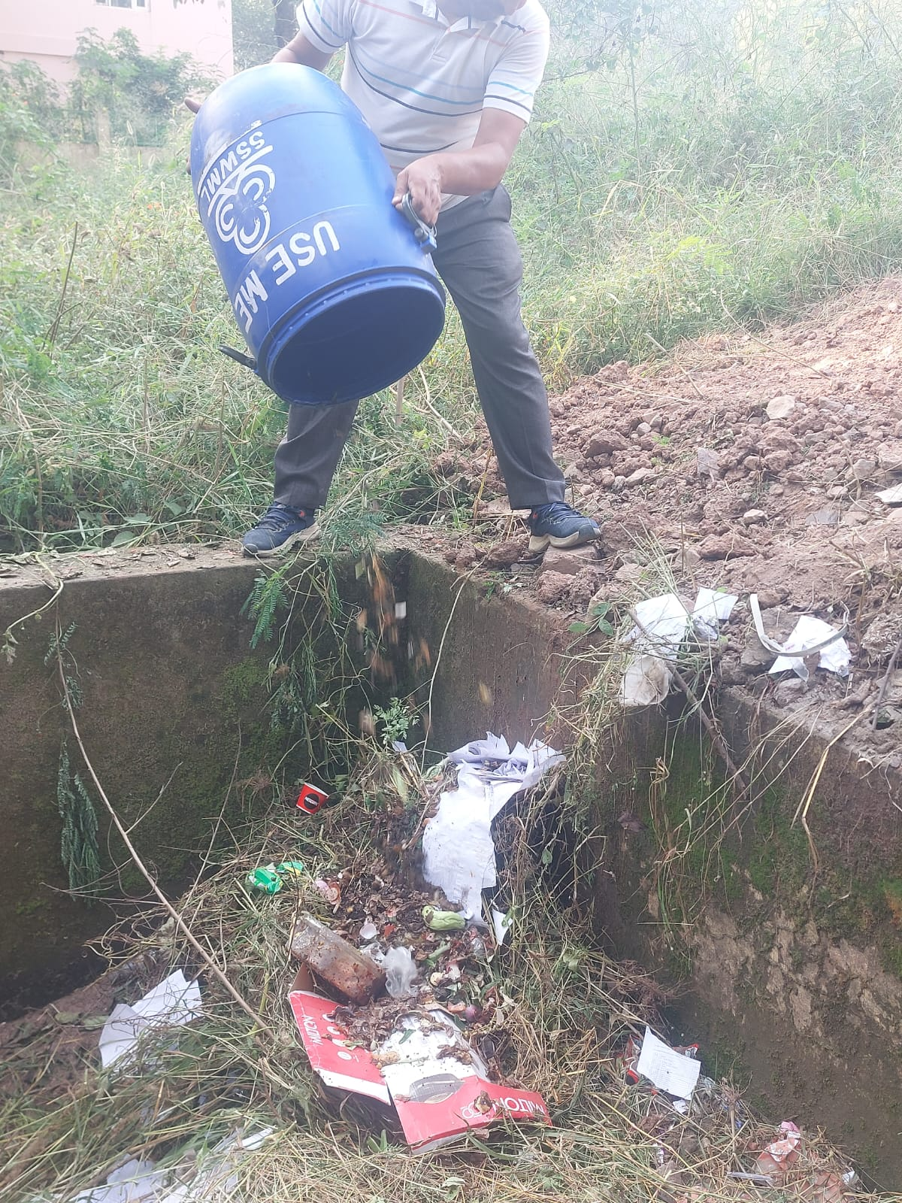
SOLID KITCHEN BIODEGRADABLE WASTE USED FOR VERMICOMPOST UNIT

ENVIRONMENTAL AWARENESS AND STUDENTS’ PARTICIPATION
Van Mahotsav:
- Annual Event: Organized by the college's Eco Club, NSS and NCC units every July during the monsoon season. Students, staff, and local communities come together to plant trees as part of this environmental awareness campaign.
- Participation: More than 500 saplings planted every year, helping to enhance the green coverage of the campus and surrounding areas.
Eco Club, Rovers & Rangers, NSS, NCC Initiatives:
- Awareness Campaigns: The Eco Club, Rovers & Rangers ,NSS, NCC regularly conduct workshops on sustainability, energy conservation, plantation drives and waste managementin the college campus. These activities encourage students to adopt eco-friendly practices in their daily lives.
- Student Participation: The Van Mahotsav celebration has become a cornerstone event, with active involvement from the student body and faculty in environmental projects.
- Landscaping: Creating aesthetically pleasing landscapes in a college setting not only enhances the beauty of the environment but also fosters a sense of calm, inspiration, and pride among students and staff. The key to effective landscaping lies in designing spaces that are visually appealing, functional, and sustainable, while reflecting the institution’s identity and values.To begin with, incorporating native plants is essential. Native flora not only thrive in the local climate with minimal maintenance but also promote biodiversity by attracting local wildlife. This contributes to a harmonious ecosystem, while the varied textures, colours, and forms of these plants offer year-round visual interest. Combining trees, shrubs, and flowering plants creates layers of greenery, adding depth and complexity to the landscape.
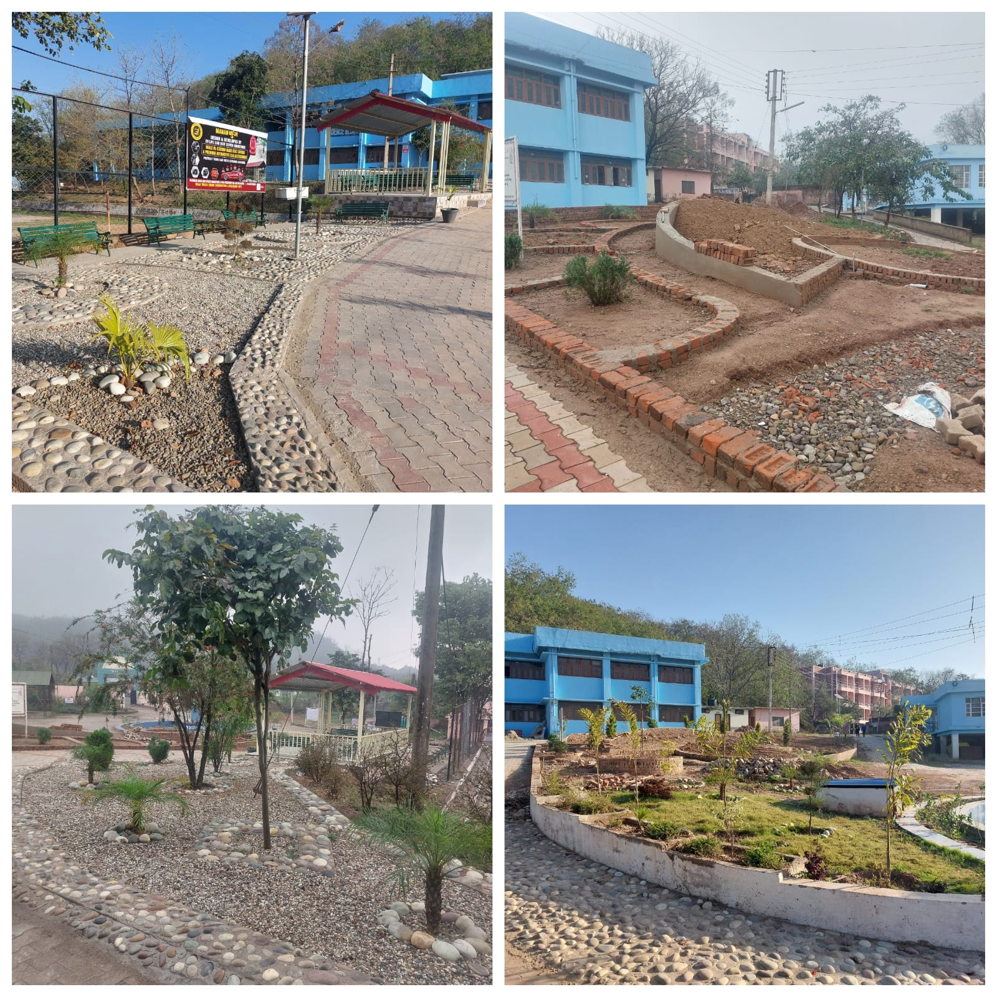
LANDSCAPING IN COLLEGE CAMPUS

SUGGESTIONS/AREAS FOR IMPROVEMENT
- The height of railing in corridors should be raised, especially of upper floors, for safety.
- The interiors of rooms receiving less light and using artificial light in ground floor of Science Bock can be modified for more effectiveness.
Air quality
- The Air Quality Index (AQI) of Nalagarh, a town in Himachal Pradesh, typically falls in the range of 100 to 200. This range indicates a moderate to unhealthy level of air quality, depending on the season and local industrial activities. Nalagarh, being an industrial hub with numerous factories, often experiences air pollution levels. There is no pollution monitoring or air quality monitoring centre of HP State Pollution Control Board. Neither College has any such mechanism.
- Most of students come to college on foot or by public transport. The transport is one of main areas of concern among students. Many staff members come to college by sharing vehicles while some staff members use pedestrian mode. On an average about 20 cars and 70 two wheelers enter the premises daily. Sharing of vehicles by staff and students and using pedestrian modes is helping in minimizing vehicular emission.
- The Fume hood is available in chemistry department to prevent from exposure to toxic fumes.
- All Labs and washrooms are equipped with exhaust fans.
- The dust and noise was found in the campus due to highway traffic.
- Few Signage boards should be put along front road of College.
Suggestions/Area to improve
- Staff and students should be motivated to purchase vehicles using power source other than fossil fuel, if at all they have to purchase any in future.
- A proposal to construct a pedestrian path from town to college may be placed to administration and other concerned authorities. This will benefit the students and staff as well the residents of the area and more people may prefer to walk to and from their work place and town. This will ensure safety and contribute to reducing vehicular traffic.
- The college can explore the possibility of own Bus/ or a bus on contract that plies at regular intervals. Many staff members and local students who are using own vehicles can shift to public transport mode. This may also solve the problem faced by students in commuting daily.
- The construction site should be separated by erecting temporary partitions/ enclosures to control dust and noise.
Energy sources and their usage
- LPG fuel is used in Canteen and Chemistry Lab. In Botany, Zoology and also in Chemistry labs electrical heating plates, heating coils and ovens are used for heating.
- The saving in power consumption for lighting has been achieved by installing LED bulbs in all places in College campus.
- Messages/ Signages with appeal to switch off electrical appliances, when not in use, are displayed at some places.
- All Air conditioners carry 5 star rating.
- All fans and lights have individual switches (no multiple connections) and so only required (need based) number can be switched on. However label on switch boards, indicating which particular light/ fan will be switched on/off, is lacking at many places.
Suggestions/ Area to Improve
- Better/ Higher star rating appliances may be given preference during purchase in future
- Signages/ messages for power conservation should be put in all classrooms, laboratories, faculty rooms and office.
- Labels can be put on all multiple switch boards so that only desired device can be switched on/off.

Water usage
- The college receives the municipal water supply the quality of which is ensured by IPH department.
- The water purifiers are installed in the college campus to provide safe drinking water to students and staff.
- Adequate water supply is a problem many times and is also area of discontent among students. The water supply and management committee looks after this issue/problem. Plumbing services are hired whenever need arises.
- The Rain water is collected/ harvested and used for gardening and construction work.
- The messages/signages to save water are put in washrooms and on water coolers.
- There is no mechanism to treat and recycle the used water.

Suggestions/ Areas to improve
- The provision for regular and adequate water supply should be made by pursuing the matter with related authorities more vigorously. At the same time, the efforts on sensitization about water conservation can be increased.
- The data on total requirement, consumption and supply need to be assessed/prepared.
- The water harvesting system can be strengthened.
- A schedule for cleaning / service of water storage tanks and water purifiers should be prepared, displayed and maintained.
Paper usage
- The main office work is paper based. Admission process is through on-line prospectus and forms. Digitalization and fee collection through online mode (via bank mode) has been going on for last two years.
- Prints and photocopies are taken on both sides wherever possible
- Internal communications on many routine matters is through WhatsApp and e-mail ensuring prompt delivery and paper saving.
- The communication to students is through notices and announcements in classrooms. One digital notice board is available.
- Digitization of library is in progress
- The examination forms and fee deposit is on- line
- There is a prescribed mechanism to write off of books and magazines.
- At the end of the semester or the academic year, students submit an assignment or project report to every course teacher. Overall a large number of notebooks are collected and many of them have unwritten/ unused pages.
Suggestions/Areas to improve
- More digital notice boards can be installed to save paper.
- Switching over to online submission or soft copy of assignments and project reports or at least, giving the option between soft copy/ on line and hard copy can lead to paper saving.
- Digitalization of office record should be done and an electronic record management system be evolved.
Waste management
- Waste segregation is practiced in college. Wet and dry waste is collected in bins with color codes. Many students are aware of it and follow the practice. The sanitation staff helps in final segregation.
- The campus was clean and well maintained except few places where dust and unorganized stacking of articles was found. Due to ongoing construction the debris and dust was found at few places. The washrooms were clean, well maintained, and are provided with exhaust fans. However the inadequate water poses a challenge for their maintenance. The storage drums are available in some washrooms.
- The vermicomposting unit has been constructed to prepare compost from waste from kitchens of Canteen and hostel and other safe organic waste generated.
- The non-biodegradable waste is handed over to MC Nalagarh for further processing as per prescribed guidelines. The old newspapers and other recyclable materials are auctioned/ sold and sent for recycling.
- There exists a mechanism for e- waste disposal. The e-waste generation is limited. During the period under report no e-waste has been disposed of although a list of articles have been prepared to send unusable articles to designated concern.
- Waste bottles/ containers have been used to raise plants in Botany and Chemistry departments.

Suggestions/ Areas to improve
- All students should be made aware and motivated for put the waste at appropriate place to facilitate segregation.
- The special sensitization drive on waste management and sanitization may be conducted.
- The sensor based urinals may be installed in future when old are to be replaced.
Landscaping and Green Initiatives
- A green belt of trees and shrubs exist around college building. This helps in absorbing dust and noise emanating from the main road and surroundings.
- There are lush green grown trees of different species in the campus.
- Two green patches with grass and ornamental plants present in front of the building in corridors and in front of Administrative Block enhances the aesthetics.
- Five special plantation drives were held in the college campus during the period under report. The members of Eco Club, NSS, NCC, Rangers and Rovers and other students were involved in these drives.
- The plantation drives were also held at other places around Nalagarh in collaboration with different agencies like Forest Department, Environment Society of Nalagarh (NGO) etc.
- No chemical fertilizers, insecticides and pesticides are used in the College. As own compost is inadequate, some vermicompost is purchased from market to meet the needs.
- About 500 saplings of medicinal, ornamental and avenue trees/ shrubs were procured from Forest department and under CSR free of cost for plantation in and around campus.
- Some of plants could not survive due a) Harsh weather conditions of Nalagarh b) High temperature and dry soil, c) Lack of full time manpower.
- Vertical gardening has been done at some places in the campus.
- Plantation by and in the presence of dignitaries has been done on special occasions like Prize distribution Function, Special Visits. It is a healthy practice of the institute to spread the message of importance of plantation cover to society
- Awareness Lectures on Importance of Forests, Biodiversity, Ozone layer, sustainable environment were delivered by experts during the session.
- The college has installed fire extinguishers to check any accident due to fire and protect life and environment.
- There is a buffer zone of vegetation between the college building and road. A forest is present in vicinity. Overall, the college has an eco-friendly environment.

Suggestions/ Areas to improve
- The indoor plants can be put in all rooms, labs, office and corridors.
- The detail documentation of plant and animal diversity of campus and surroundings may be done by involving students.
- The Plates containing brief information about different plants may be put in front of different trees to make students aware and understand the importance.
- A proposal for creation of full time post of gardener can be sent to Government.
- The responsibility of every new plant or saplings should be entrusted to a particular student/ staff member and the record of the same may be maintained to enhance care and survival rate.
Conclusion
Govt. College Nalagarh is well on its way to becoming a model for sustainability in higher education institutions. With over 70% green coverage, a functioning rainwater harvesting system, and installed solar panels, the college has demonstrated its commitment to environmental stewardship. For the 2025-2026 academic year, the focus will be on strengthening water management, completing the Botanical Garden, and further reducing the ecological footprint through heightened awareness campaigns.

Green Audit Committee:
- Prof Sanjay Sharma, Assistant Professor in Physics, Convenor

- Dr. Naveeta Sharma, Assistant Professor in Geography, Member

- Prof Sonia Mohil, Assistant professor in Sociology, Member

- Prof Davesh Sharma, Assistant Professor in Philosophy, Member

Principal

