Student satisfaction survey (2017-2018)
Introduction
Student’s satisfaction provides auditable evidence that students have opportunity to assess and comment on strength and weakness on teaching learning process.
Satisfaction level of students is decided by kind of experiences, extent of comfort feeling, opportunity for intellectual stimulation showing the actual quality of teaching learning process. It is impractical to capture satisfaction from every student so random Sample Survey is carried out.
This feedback is based on the inputs received from the students in the physical as well as digital format and allowing them to freely and fairly put their concern and views regarding the institution.
Mode of collection data
The various components of questionnaire are:
1. Syllabus coverage
2. Teacher’s preparation
3. Communication skills of teacher
4. Teacher’s approach
5. Fairness of internal evaluation process
6. Opportunities to grow
7. Career counseling
8. Learning follow up
9. Motivational skills of teacher
10. Ability of teachers to shape the students
11. Motivation to participate in extracurricular activities
12. Promotion to inculcate soft skill, life skill and employability
13. Use of ICT tools in teaching process
14. Overall quality of teaching learning process
The main objective of the feedback system:-
• To develop communication channel between the administration and students.
• To evaluate effectiveness of overall education imparted to students
• To check areas where improvement can be made in near future
• To see the outcomes of counseling of students
Analysis inferences and outcome
The feedback obtained from Student is analyzed by using available statistical tools. The inferences drawn are used for improvement of functioning of the college in general and teaching-learning process in particular.

Graph
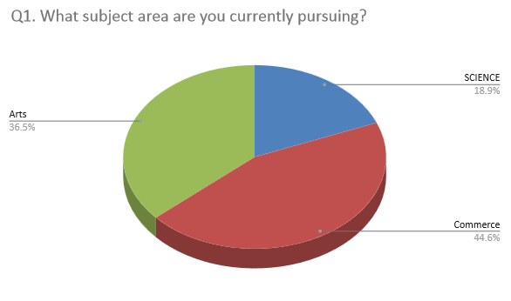

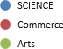

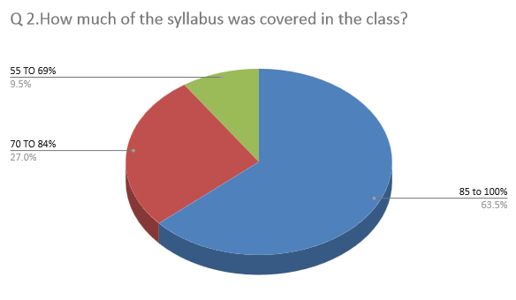
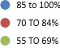

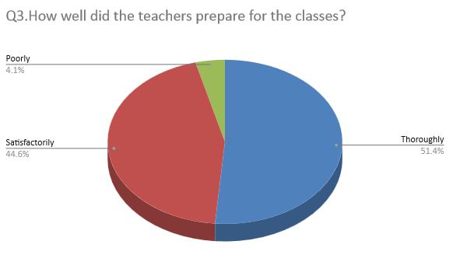
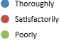

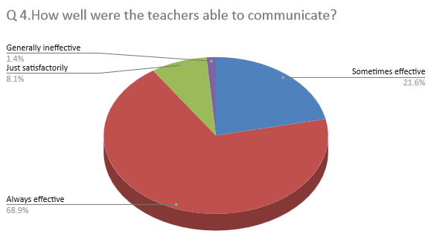
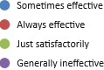

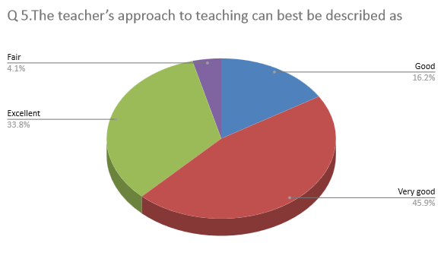
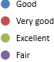
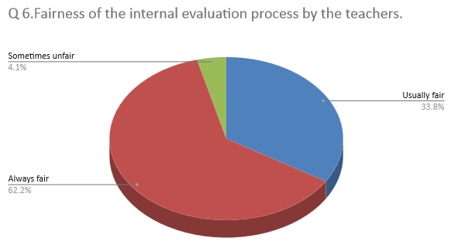
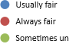fair
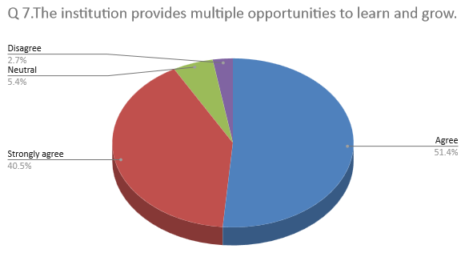
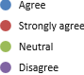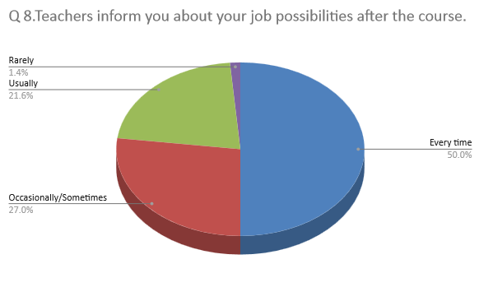
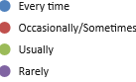
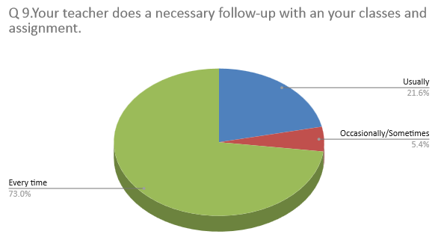
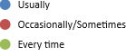

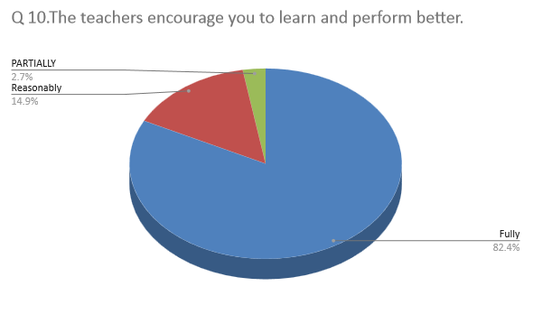
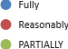
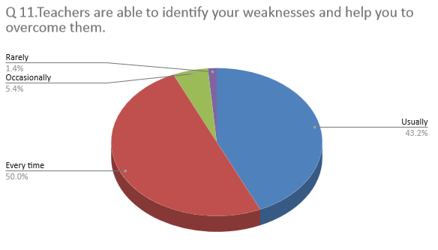
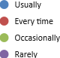

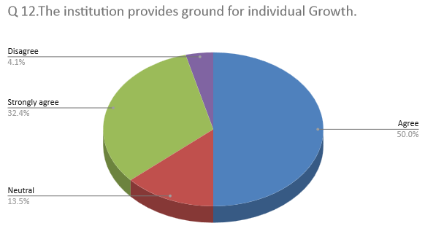
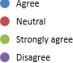

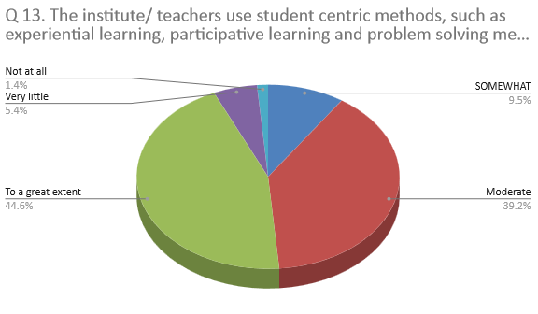
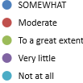

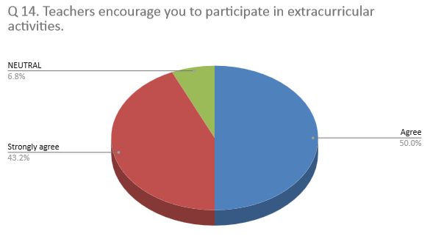
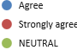

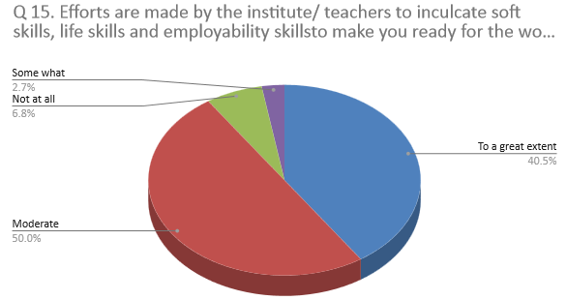

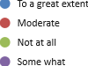

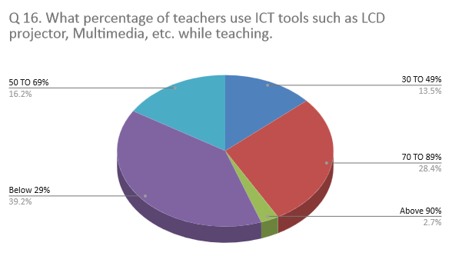
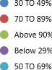

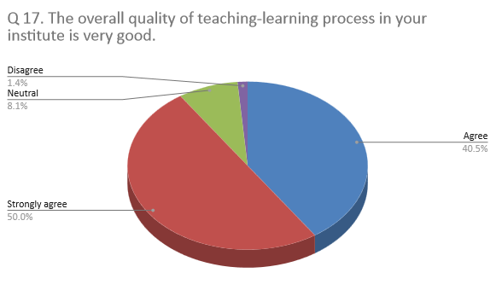
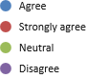
Overall feedback analysis
The various graphs present the different views expressed by students according to their perception of the quality of education in the institution. After analysis of the data it has been observed that students are satisfied with teaching learning process of the institution. The survey results clearly depict that syllabus is completed well in time and most of the students are satisfied with the teacher’s preparations. Majority of the students are in agreement that the process of the teachers internal evaluation is fair and transparent. Students also appreciated the fact that multiples opportunities are provided to them for extracurricular activities by the institution for their overall growth. Students satisfactory survey showed that overall quality of teaching learning process in this institution is very good. But more frequent and effective use of ICT by teachers in need of hour as reflected in analysis of survey.

