Student satisfaction survey

Introduction
Students’ satisfaction is an important component of teaching learning process in the college. The student satisfaction survey provides auditable evidence that students have had the opportunity to share their experience which can be utilized by the college to bring qualitative improvement. The students get an opportunity to explain their satisfaction level on their academic experiences, teaching learning process, opportunities and facilities available in the institution.
The college assess the satisfaction of students in course quality, interaction with teachers, teachers follow up, peer collaboration and overall quality of teaching learning process. The student feedback assesses the quality of teaching and the infrastructure available/ required for quality teaching.
The feedback based on the inputs received from the students in the physical as well as digital format is obtained from the students allowing them to freely and fairly put their concerns and views regarding the institution. The feedback is divided in to various broad categories starting with curriculum, teaching process evaluation, overall development and outcome of programmes.

Mode of collection of data
The data was collected through sample survey from the students of various facultieswith the help of a questionnaire devised for this purpose.
- The various components included in the questionnaire are
- Syllabus Coverage
- Teacher’s Preparation
- Communication Skills of teacher
- Teacher’s Approach
- Fairness of Internal Evaluation Process
- Opportunities to grow
- Career Counselling
- Learning Follow Up
- Motivational Skills of Teacher
- Ability of teacher to shape the students
- Motivation to participate in Extracurricular Activities
- Promotion to inculcate Soft skill, life skill and Employability
- Use of ICT tools in teaching process
- Overall Quality of Teaching Learning Process

The Main Objective of the feedback System:-
Number of responses recorded for the student satisfaction survey was the measure the student level of satisfaction. The institute covering the teaching learning process in the area shown below:
- To develop a communication channel between the management and students
- To improve the function of the college and ultimately achieve the excellence in the diverse field like library, sports, administrator etc.
- Feedback has a significant effect on student learning and assessment process.

Analysis, Inferences and Outcome
The feedback obtained from students is analysed by using available statistical tools. The inferences drawn are used for improvement of functioning of the college in general and teaching- learning process in particular.

Results
Student Satisfaction Survey Session 2016-17
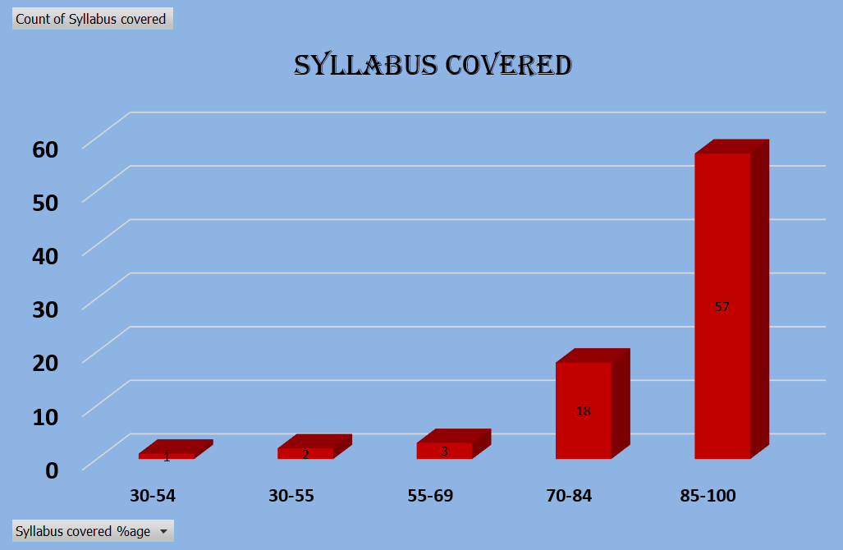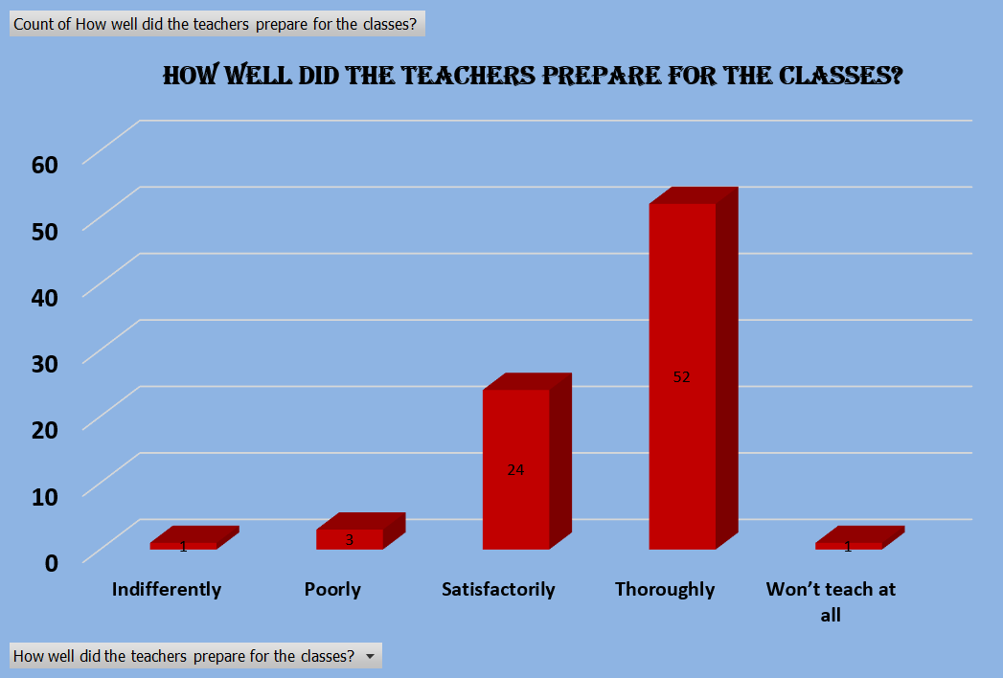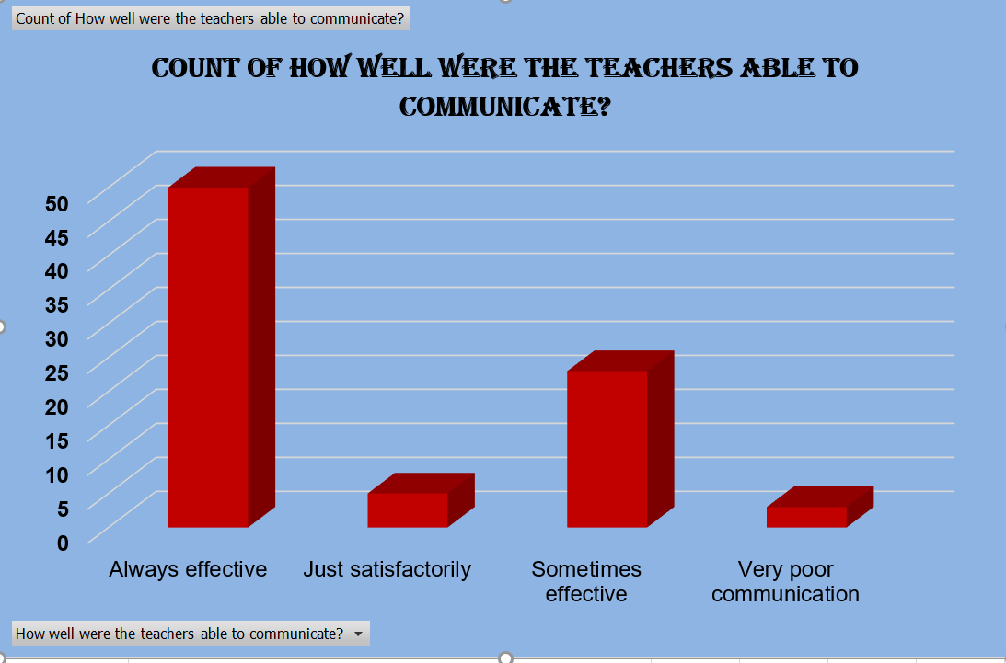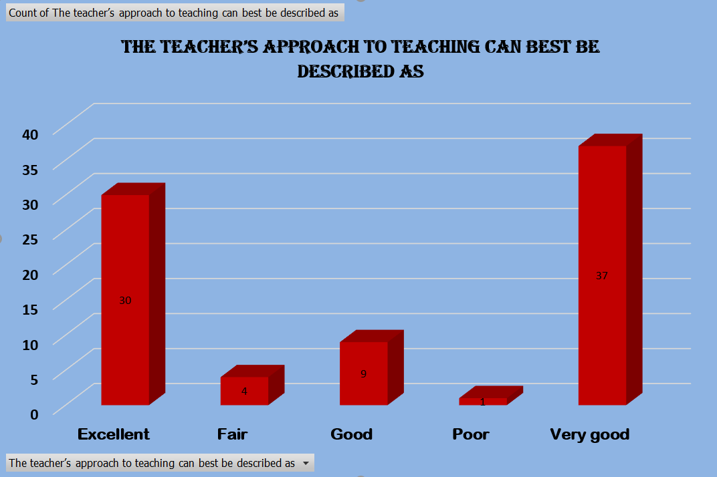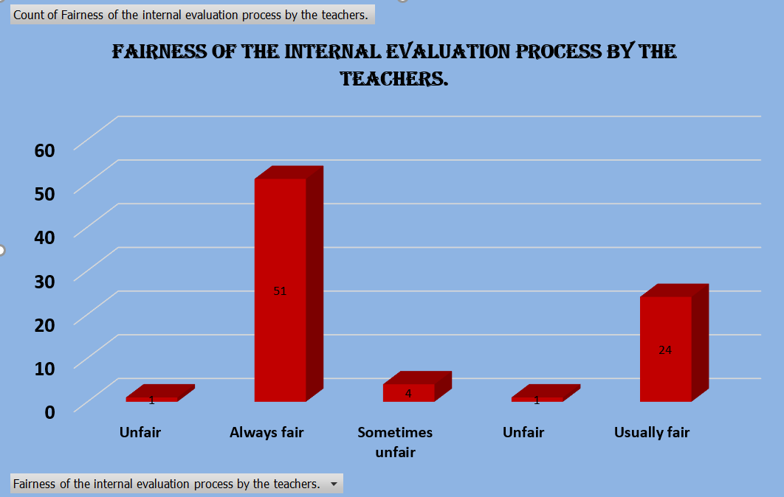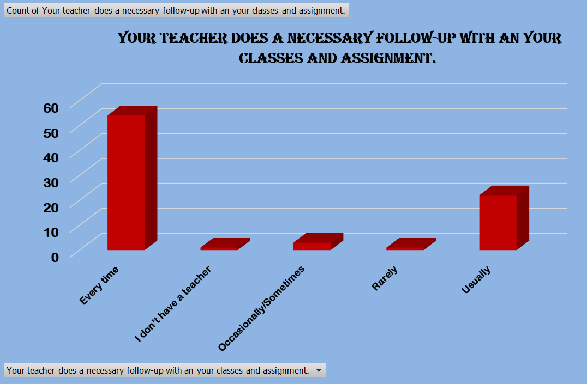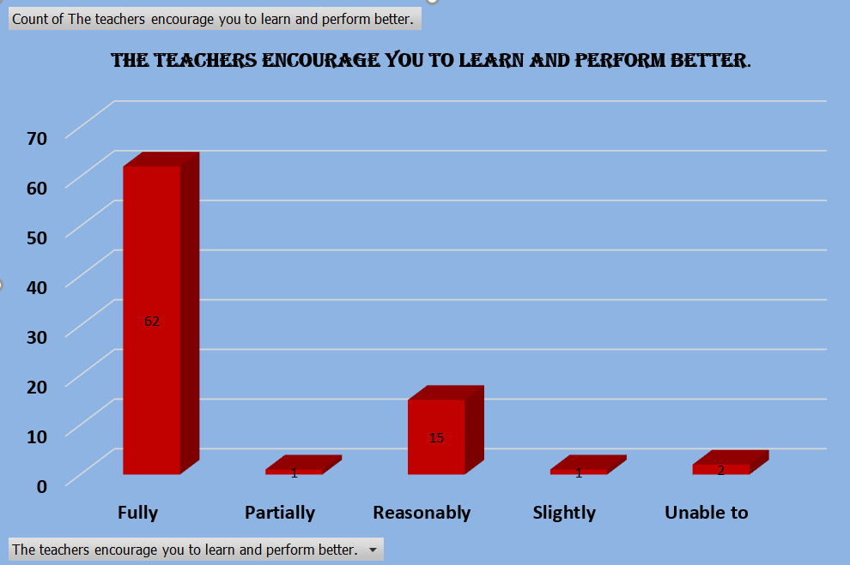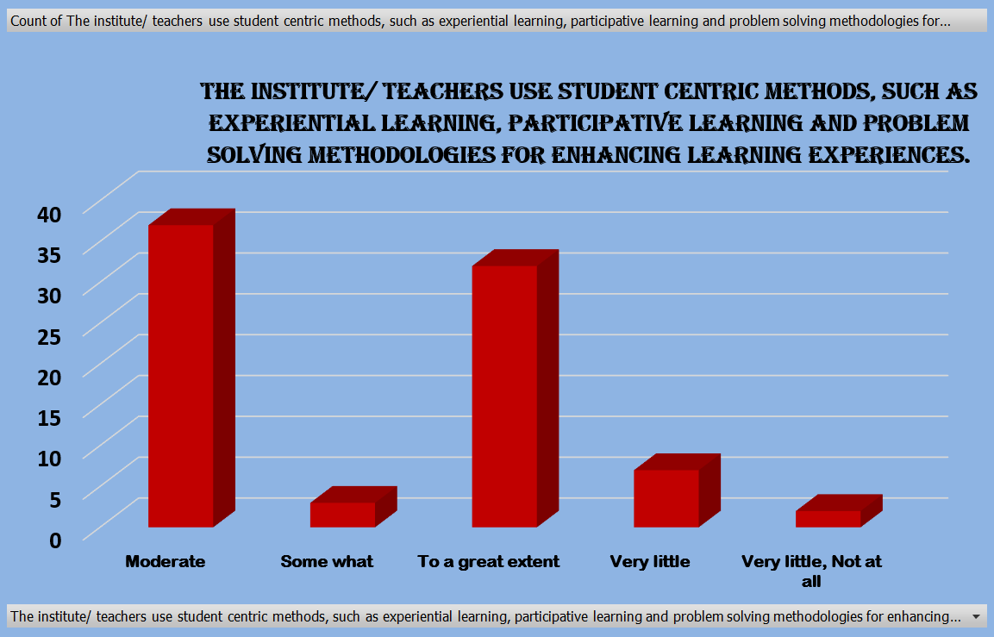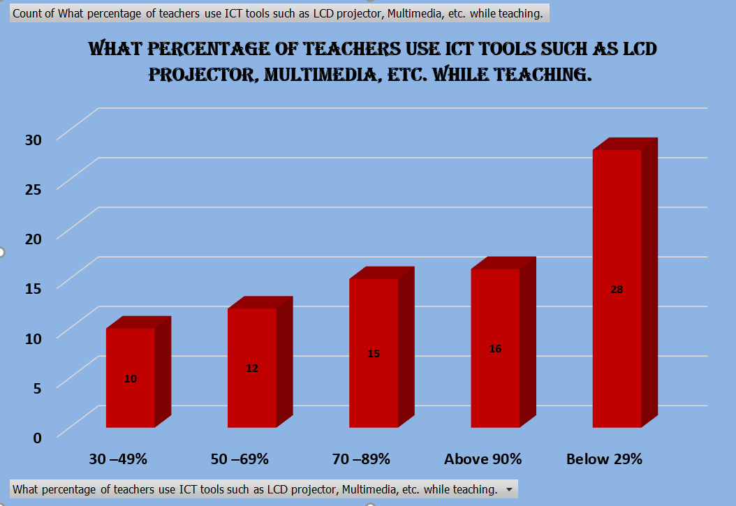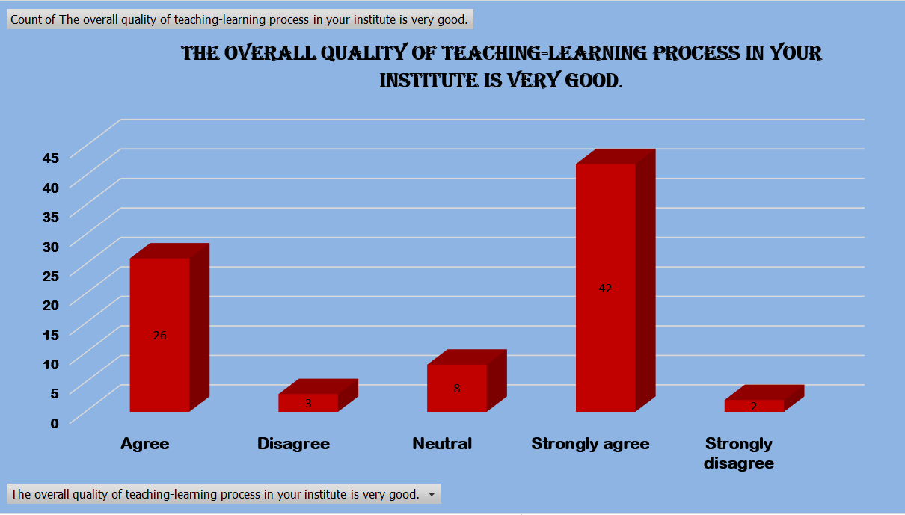

Overall Feedback Analysis
From the analysis of students’ survey, it is clear that majority of students feels that teaching and mentoring process of the institution enhanced their cognitive, social and emotional growth. Comprehensive assessment of the survey forms received, it was found that syllabus was completed well in time and most of students satisfied by the teachers preparations most of the students consented that process of the teachers internal evolution is fair and transparent. Students also appreciated multiples opportunities, including the platform provided for extracurricular activities being provided by the institution for their overall growth. Student Satisfactory survey showed that overall quality of teaching learning process in this institution is very good.

